Name

Mathematics Extension 1 Year 12
Introduction to
Vectors

Book 2 | Further operations with vectors | Version: 261028  Feedback:  https://MrDingMaths.com
Contents
Syllabus Content 2
The Dot Product Algebraic Formula 3
The Dot Product Geometric Formula 5
Properties of the Dot Product 9
Proofs using Vectors 15
Vector Projection 26
Applications of Vectors to Motion 35
Applications of Vectors to Mechanics 44

Syllabus Content
ME1-12-02 operates with 2D and 3D vectors and uses 2D vectors to solve problems involving motion in two dimensions
Further operations with vectors
- Define $a⋅b=x_{1}x_{2}+y_{1}y_{2}$ as the scalar (dot) product of vectors $a=x_{1}i+y_{1}j$ and $b=x_{2}i+y_{2}j$ and use the scalar product to solve problems
- Define $a⋅b=x_{1}x_{2}+y_{1}y_{2}+z_{1}z_{2}$ as the scalar product of vectors $a=x_{1}i+y_{1}j+z_{1}k$ and $b=x_{2}i+y_{2}j+z_{2}k$ and use the scalar product to solve problems
- Use $a⋅b=\left|a\right|\left|b\right|cos θ$ as a geometric expression of the scalar product of non-zero vectors $a$ and $b$ in two dimensions and three dimensions, where $θ$ is the angle between the vectors and $0°≤θ≤180°$.
- Verify the equivalence of $a⋅b=\left|a\right|\left|b\right|cos θ$ with the algebraic definition of the scalar product, $a⋅b=x_{1}x_{2}+y_{1}y_{2}$ for two dimensions and $a⋅b=x_{1}x_{2}+y_{1}y_{2}+z_{1}z_{2}$ for three dimensions
- Derive and use the property $a⋅a={\left|a\right|}^{2}$ to establish the scalar product definition of the magnitude of a vector ($\left|a\right|=\sqrt{a⋅a}$) in two dimensions and three dimensions
- Calculate the angle between two non-zero vectors $a$ and $b$, in both two dimensions and three dimensions, using the scalar product by deriving and applying the relationship $cos θ=\frac{a⋅b}{\left|a\right|\left|b\right|}=\left(\hat{a}⋅\hat{b}\right)$
- Establish $a⋅b=0$ as a condition for two non-zero vectors $a$ and $b$ to be perpendicular to each other and use it to determine if two vectors are perpendicular
- Establish $a⋅b=±\left|a\right|\left|b\right|$ as another way to determine if two non-zero vectors $a$ and $b$ are parallel
- Define the projection of a vector $a$ onto a vector $b$, denoted by ${proj}_{b}a$, to be the vector component of $a$ in the direction of vector $b$
- Examine the proof of the formula ${proj}_{b}a=\left(\frac{a⋅b}{{\left|b\right|}^{2}}\right)b=\left(a⋅\hat{b}\right)\hat{b}$ and use the formula to solve problems
- Determine that the component of a vector $a$ perpendicular to another vector $b$ is $a-{proj}_{b}a$

The Dot Product Algebraic Formula

- Dot Product Algebraic Formula
For $\overset{̰}{a}=x_{1}i+y_{1}j$ and $\overset{̰}{b}=x_{2}i+y_{2}j$, the dot product of $\overset{̰}{a}$ and $\overset{̰}{b}$ is:

$$\overset{̰}{a}⋅\overset{̰}{b}=x_{1}x_{2}+y_{1}y_{2}$$
- Some textbooks refer to the dot product as the scalar product.
This booklet will avoid this as it can be easily confused with multiplication by a scalar ($λ\overset{̰}{a}$)

- Example Calculate dot product using algebraic definition.
Find $\overset{̰}{u}⋅\overset{̰}{v},$ given $\overset{̰}{u}=7i+3j$ and $\overset{̰}{v}=-i+6j.$  $$\overset{̰}{u}⋅\overset{̰}{v}=\left(7\right)\left(-1\right)+\left(3\right)\left(6\right) \\ =11$$ | Find $\overset{̰}{a}⋅\overset{̰}{b},$ given $\overset{̰}{u}=2j-3i$ and $\overset{̰}{b}=\frac{4}{3}i-12j.$  $$\overset{̰}{a}⋅\overset{̰}{b}=\left(-3\right)\left(\frac{4}{3}\right)+\left(2\right)\left(-12\right) \\ =-28$$

- Practice
- Find $\overset{̰}{u}⋅\overset{̰}{v}$, given:  $\overset{̰}{u}=3i-4j$, $\overset{̰}{v}=i+2j$  $$-5$$ | - Find $\overset{̰}{u}⋅\overset{̰}{v}$, given:  $\overset{̰}{u}=\left(\begin{aligned}2 \\ 5\end{aligned}\right), \overset{̰}{v}=\left(\begin{aligned}-3 \\ 4\end{aligned}\right)$  14
- Find $\overset{̰}{u}⋅\overset{̰}{v}$, given:  $\overset{̰}{u}=\left(\begin{aligned}\frac{1}{\sqrt{2}} \\ \frac{1}{\sqrt{2}}\end{aligned}\right), \overset{̰}{v}=\left(\begin{aligned}0 \\ 12\end{aligned}\right)$  $$\frac{12}{\sqrt{2}}=6\sqrt{2}$$ | - Find $\overset{̰}{u}⋅\overset{̰}{v}$, given:  $\overset{̰}{u}=6\cos{30°}i-6\sin{30°}j$,  $\overset{̰}{v}=-2\cos{45°}i-2\sin{45°}j$  $$-3\sqrt{6}+3\sqrt{2}$$

Foundation
- Find $\underset{∼}{a}·\underset{∼}{b}$ given:
- $\underset{∼}{a}= \left(\begin{aligned}3 \\ 1\end{aligned}\right),\underset{∼}{b}= \left(\begin{aligned}2 \\ 4\end{aligned}\right)$  $$10$$ | - $\underset{∼}{a}= \left(\begin{aligned}-8 \\ -5\end{aligned}\right),\underset{∼}{b}= \left(\begin{aligned}6 \\ -14\end{aligned}\right)$  $$22$$
- $\underset{∼}{a}= \left(\begin{aligned}6u \\ -2v\end{aligned}\right),\underset{∼}{b}= \left(\begin{aligned}3v \\ 9u\end{aligned}\right)$  $$0$$ | - $\underset{∼}{a}= \left(\begin{aligned}x-1 \\ x-2\end{aligned}\right),\underset{∼}{b}= \left(\begin{aligned}x-1 \\ x+2\end{aligned}\right)$  $$2x^{2}- 2x - 3$$

- Find the scalar product $\underset{∼}{u}·\underset{∼}{v}$ to 1 decimal place, given:
- $\underset{∼}{u}= \left(\begin{aligned}3 \\ 2\end{aligned}\right),\underset{∼}{v}= \left(\begin{aligned}-1 \\ 5\end{aligned}\right)$  $$3\left(-1\right)+ 2\left(5\right)= 7$$ | - $\underset{∼}{u}= \left(\begin{aligned}4 \\ -1\end{aligned}\right),\underset{∼}{v}= \left(\begin{aligned}-2 \\ 7\end{aligned}\right)$  $$4\left(-2\right)+ \left(-1\right)\left(7\right)= -15$$ | - $\underset{∼}{u}= \left(\begin{aligned}6 \\ 3\end{aligned}\right),\underset{∼}{v}= \left(\begin{aligned}-4 \\ 8\end{aligned}\right)$  $$6\left(-4\right)+ 3\left(8\right)= 0$$
- $\underset{∼}{u}= 4i - j,$  $$\underset{∼}{v}= i - 5j$$  $$4\left(1\right)+ \left(-1\right)\left(-5\right)= 9$$ | - $\underset{∼}{u}= -3i + 4j,$  $$\underset{∼}{v} = 2i + 3j$$  $$\left(-3\right)\left(2\right)+ 4\left(3\right)= 6$$ | - $\underset{∼}{u}= i - 9j,$  $$\underset{∼}{v}= -3i - 2j$$  $$1\left(-3\right)+ \left(-9\right)\left(-2\right)= 15$$

- The dot product of $\left(\begin{aligned}x \\ 2\end{aligned}\right)$ and $\left(\begin{aligned}-4 \\ 5\end{aligned}\right)$ is 14. Find the value of $x$.

$$\left(\begin{aligned}x \\ 2\end{aligned}\right)· \left(\begin{aligned}-4 \\ 5\end{aligned}\right)= 14 \\ -4x + 10 = 14 \\ -4x = 4 \\ x = - 1$$

- The dot product $\underset{∼}{u}·\underset{∼}{v}= 24$ where $\underset{∼}{u}= \left(\begin{aligned}x \\ 3\end{aligned}\right)$ and $\underset{∼}{v}= \left(\begin{aligned}-1 \\ 4\end{aligned}\right).$ Find the value of $x$.

$$\underset{∼}{u}·\underset{∼}{v}= x\left(-1\right)+ 3\left(4\right)= 24 \\ -x + 12 = 24 \\ x = -12$$

The Dot Product Geometric Formula

- Angle between two vectors
The angle between two vectors $θ$ is the angle formed when the two vectors are placed
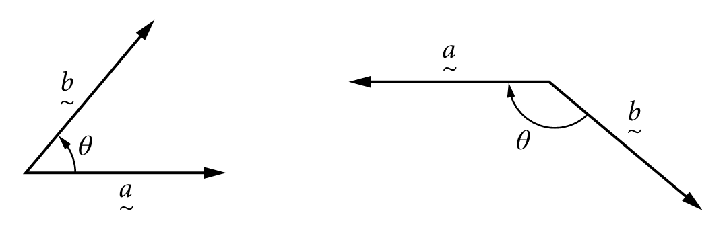
tail-to-tail. By convention, $θ$ cannot be the reflex angle, so $0≤θ≤180$.

- The head-to-head angle is equivalent, but we do not call this the angle between two vectors.

- Identify angle between two vectors.
✖  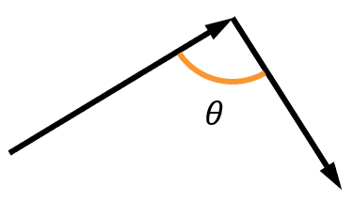 | ✔  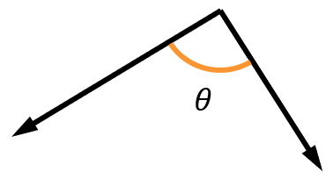 | ✔  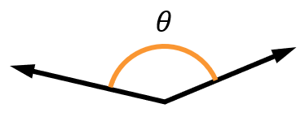 | ✖  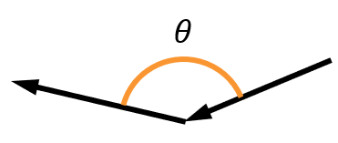
Identify which of the following diagrams correctly shows the angle between two vectors.
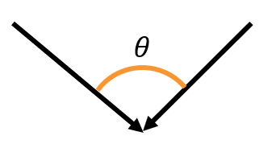 | 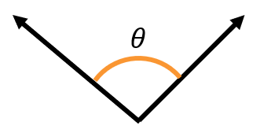 | 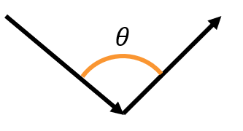 | 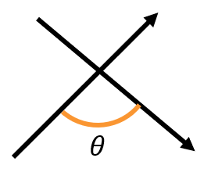
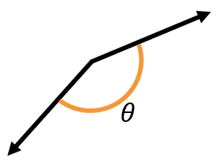 | 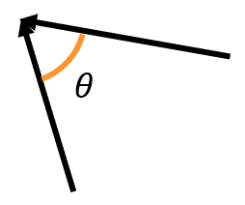 | 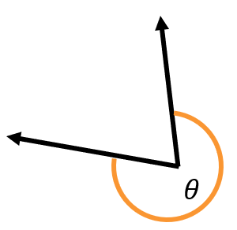 | 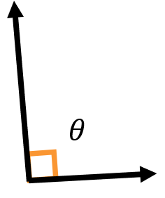

- Dot Product Geometric Formula
For the angle $θ$ between two vectors $\overset{̰}{a}$ and $\overset{̰}{b}$:

$\overset{̰}{a}⋅\overset{̰}{b}=\left|\overset{̰}{a}\right|\left|\overset{̰}{b}\right|\cos{θ}$

- You can also use the reflex angle, since $\cos\left(360-θ\right)=\cos{θ}$

- Example Calculate dot product using geometric definition.
Find $\overset{̰}{a}⋅\overset{̰}{b},$ given $\left|\overset{̰}{a}\right|=5$ and $\left|\overset{̰}{b}\right|=6$.  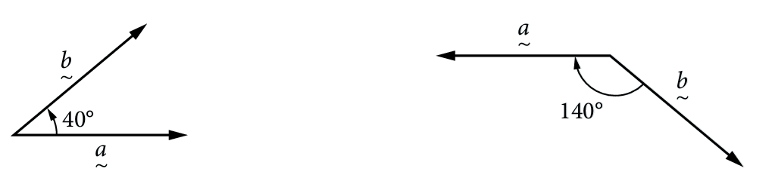  Answer to 2 d.p.  $$\overset{̰}{a}⋅\overset{̰}{b}=\left(5\right)\left(6\right)\cos{40°} \\ =22.98$$ | Find $\overset{̰}{a}⋅\overset{̰}{b},$ given $\left|\overset{̰}{a}\right|=11$ and $\left|\overset{̰}{b}\right|=2$  Answer to 2 d.p.  $$\overset{̰}{a}⋅\overset{̰}{b}=\left(11\right)\left(2\right)\cos{140°} \\ =-16.85$$

- Practice
Find the dot product to two decimal places.
- Find $\overset{̰}{a}⋅\overset{̰}{b}$ if $\left|\overset{̰}{a}\right|=3, \left|\overset{̰}{b}\right|=11$  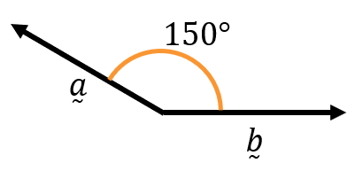  $$-28.58$$ | - Find $\overset{̰}{a}⋅\overset{̰}{b}$ if $\left|\overset{̰}{a}\right|=7, \left|\overset{̰}{b}\right|=2$  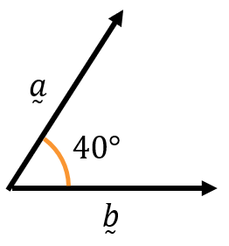  10.72
- $\overset{̰}{u}$ has length $7$ and $\overset{̰}{v}$ has length 5.  The angle between them is 74°.  Find $\overset{̰}{u}⋅\overset{̰}{v}$.  9.65 | - Given $\left|\overset{̰}{a}\right|=3$ and $\left|\overset{̰}{b}\right|=5$, find $\overset{̰}{a}⋅\overset{̰}{b}$.  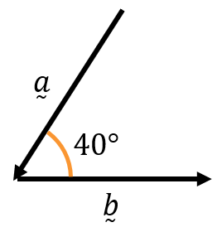  $$-11.49$$

- Angle Between Two Vectors
By rearranging the geometric dot product formula:
$$\cos{θ}=\frac{\overset{̰}{a}⋅\overset{̰}{b}}{\left|\overset{̰}{a}\right|\left|\overset{̰}{b}\right|}$$
- Calculate $\overset{̰}{a}⋅\overset{̰}{b}$ using the algebraic dot product formula: $x_{1}x_{2}+y_{1}y_{2}$
- Calculate $\left|\overset{̰}{a}\right|$ and $\left|\overset{̰}{b}\right|$ using: $\sqrt{x^{2}+y^{2}}$
- Calculate $θ$ using the above formula.

- Example Calculate angle between two vectors.
$\overset{̰}{u}=\left(\begin{aligned}4 \\ 3\end{aligned}\right)$ and $\overset{̰}{v}=\left(\begin{aligned}12 \\ -5\end{aligned}\right)$, find the angle between the two vectors, correct to the nearest degree.
1.  $$\overset{̰}{u}⋅\overset{̰}{v}=\left(4\right)\left(12\right)+\left(3\right)\left(-5\right)$$  $=33$  2.  $$\left|\overset{̰}{u}\right|=\sqrt{4^{2}+3^{2}}=5$$  $$\left|\overset{̰}{v}\right|=\sqrt{{12}^{2}+{\left(-5\right)}^{2}}=13$$ | 3.  $$\cos{θ}=\frac{33}{\left(5\right)\left(13\right)}$$  $$∴θ≈59°$$

- Practice
Find the angle between the two vectors, to one decimal place.  $\overset{̰}{a}=\left(\begin{aligned}3 \\ 1\end{aligned}\right)$ and $\overset{̰}{b}=\left(\begin{aligned}2 \\ 5\end{aligned}\right)$  $$49.8°$$ | Find the angle between the two vectors, to the nearest degree.  $\overset{̰}{r}=-i-3j$ and $\overset{̰}{s}=2i+5j$  $$177°$$

Foundation
- If $θ$ is the angle between $\underset{∼}{a}$ and $\underset{∼}{b}$, find $\underset{∼}{a}·\underset{∼}{b}$ given:
- $\left|\underset{∼}{a}\right|= 6, \left|\underset{∼}{b}\right|= 5 and θ = 60°$  $$15$$ | - $\left|\underset{∼}{a}\right|= 4, \left|\underset{∼}{b}\right|= 3 and θ = 45°$  $$6\sqrt{2}$$

- Find the angle $θ$ between the vectors $\underset{∼}{u}$ and $\underset{∼}{v}$ (nearest degree if necessary) if:
- $\left|\underset{∼}{u}\right|= 4, \left|\underset{∼}{v}\right|= 5 and \underset{∼}{u}·\underset{∼}{v}= -10$  $$120°$$ | - $\left|\underset{∼}{u}\right|= 3, \left|\underset{∼}{v}\right|= 5 and \underset{∼}{u}·\underset{∼}{v}= 12$  $$37°$$

- If $θ$ is the angle between the vectors $\underset{∼}{a}$ and $\underset{∼}{b},$ find the exact value of cos θ given:
- $\underset{∼}{a}=4i+3j, \underset{∼}{b}=5j$  $$\underset{∼}{a}·\underset{∼}{b}= 4\left(0\right)+ 3\left(5\right)= 15 \\ \left|\underset{∼}{a}\right|= 5, \\ \left|\underset{∼}{b}\right|= 5 \\ cos θ =\frac{15}{5 × 5}=\frac{3}{5}$$ | - $\underset{∼}{a}= \left(\begin{aligned}2 \\ 2\end{aligned}\right),\underset{∼}{b}= \left(\begin{aligned}3 \\ -1\end{aligned}\right)$  $$\underset{∼}{a}·\underset{∼}{b}= 2\left(3\right)+ 2\left(-1\right)= 4 \\ \left|\underset{∼}{a}\right|= \sqrt{8}, \\ \left|\underset{∼}{b}\right|= \sqrt{10} \\ cos θ =\frac{4}{\sqrt{8}× \sqrt{10}}=\frac{4}{\sqrt{80}}=\frac{1}{\sqrt{5}}$$ | - $\underset{∼}{a}= \left(\begin{aligned}-6 \\ 4\end{aligned}\right),\underset{∼}{b}= \left(\begin{aligned}-8 \\ -2\end{aligned}\right)$  $$\underset{∼}{a}·\underset{∼}{b}= \left(-6\right)\left(-8\right)+ \left(4\right)\left(-2\right)= 40 \\ \left|\underset{∼}{a}\right|= \sqrt{36 + 16}= \sqrt{52}, \\ \left|\underset{∼}{b}\right|= \sqrt{64 + 4}= \sqrt{68} \\ cos θ =\frac{40}{\sqrt{52 × 68}}=\frac{40}{\sqrt{3536}}=\frac{10}{\sqrt{221}}$$

- Find the angle between the vectors, correct to the nearest degree.
- $\underset{∼}{u}= \left(\begin{aligned}-3 \\ 4\end{aligned}\right) and \underset{∼}{v}= \left(\begin{aligned}-5 \\ 12\end{aligned}\right)$  $$\underset{∼}{u}·\underset{∼}{v}= 63 \\ \left|\underset{∼}{u}\right|= 5, \left|\underset{∼}{v}\right|= 13 \\ cos θ =\frac{63}{65} \\ θ≈ 14°$$ | - $\underset{∼}{u}= \left(\begin{aligned}1 \\ -2\end{aligned}\right) and \underset{∼}{v}= \left(\begin{aligned}-3 \\ 1\end{aligned}\right)$  $$\underset{∼}{u}·\underset{∼}{v}=-5 \\ \left|\underset{∼}{u}\right|= \sqrt{5}, \left|\underset{∼}{v}\right|= \sqrt{10} \\ cos θ = -\frac{5}{\sqrt{50}}= -\frac{1}{\sqrt{2}} \\ θ ≈ 135°$$
- $\underset{∼}{u}= \left(\begin{aligned}6 \\ -3\end{aligned}\right) and \underset{∼}{v}= \left(\begin{aligned}2 \\ 4\end{aligned}\right)$  $$\underset{∼}{u}·\underset{∼}{v}=0 \\ cos θ =0 \\ θ=90°$$ | - $\underset{∼}{u}= 2i + 5j and \underset{∼}{v}= 3i + j$  $$\underset{∼}{u}·\underset{∼}{v}= 11 \\ \left|\underset{∼}{u}\right|= \sqrt{29}, \left|\underset{∼}{v}\right|= \sqrt{10} \\ cos θ =\frac{11}{\sqrt{290}} \\ θ ≈ 50°$$

- The angle between vectors $\underset{∼}{u}$ and $\underset{∼}{v}$ is 60° and their scalar product is 10.
If $\underset{∼}{v} = 3i - 4j,$find the magnitude of $\underset{∼}{u}$.
$$\left|\underset{∼}{u}\right|\left|\underset{∼}{v}\right|cos 60° = 10 \\ \left|\underset{∼}{u}\right|× 5 × ½ = 10 \\ \left|\underset{∼}{u}\right|= 4$$

Properties of the Dot Product

- Investigation What the dot product represents
- https://www.desmos.com/geometry/0ufbyovmn1
Consider the two unit vectors $\overset{̰}{\hat{a}}$ and $\overset{̰}{\hat{b}}$ below. The dot product is shown.
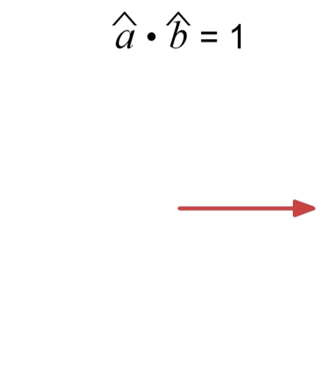 | 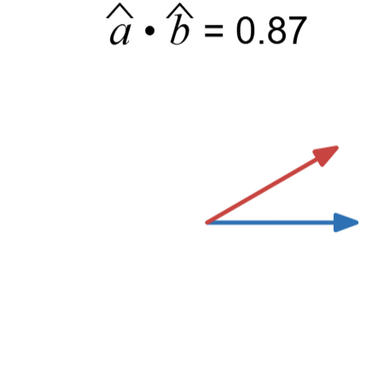  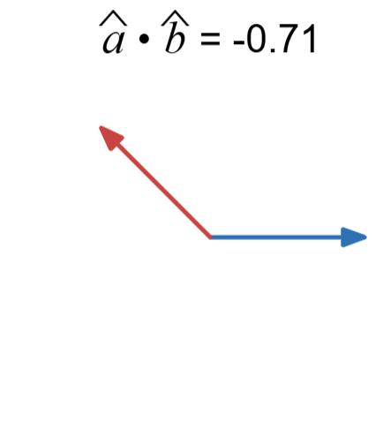 | 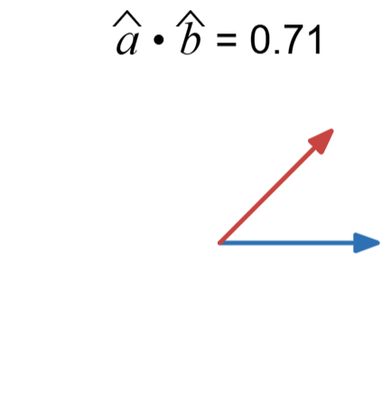 | 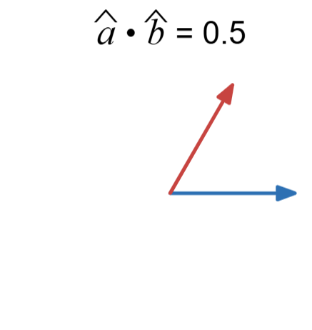  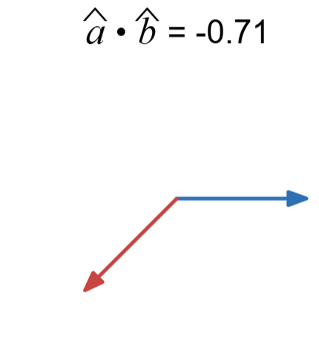
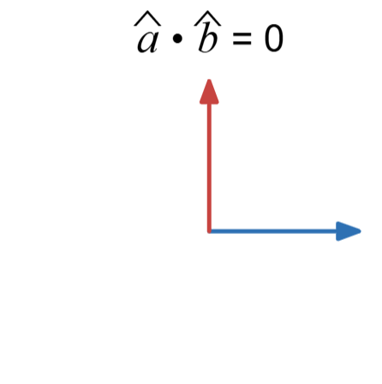 |  | 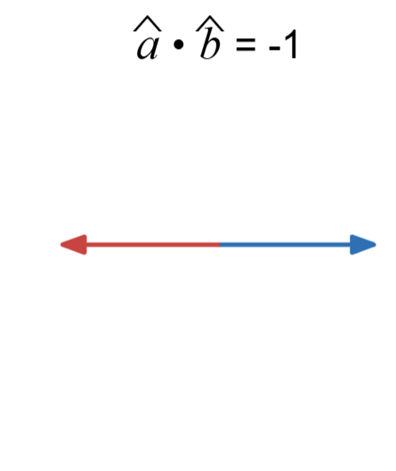
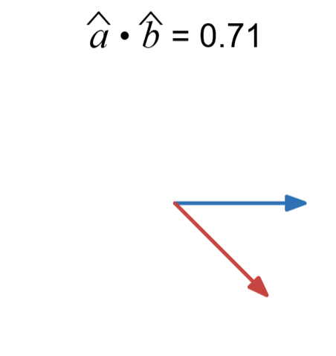
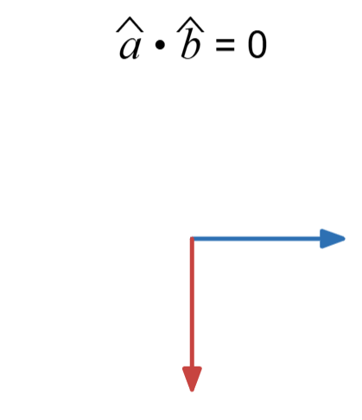

What do you think the dot product represents, when you have two unit vectors?
The dot product is a measure of how much two vectors point in the same …………………,
If two unit vectors point in the exact same direction, the dot product is ………………
If two unit vectors are ……………………, the dot product is 0.
If two unit vectors are pointing in exact …………… directions, the dot product is ……………

For two unit vectors, the dot product is given by $\overset{̰}{\hat{a}}⋅\overset{̰}{\hat{b}}=\left|\overset{̰}{\hat{a}}\right|\left|\overset{̰}{b}\right|\cos{θ}=$ ……………

- Investigation What the dot product represents
- https://www.geogebra.org/m/wph4vxjh
Consider the two vectors $\overset{̰}{u}$ and $\overset{̰}{v}$ below.
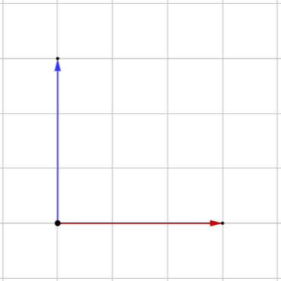  $\overset{̰}{u}⋅\overset{̰}{v}=$ …… | 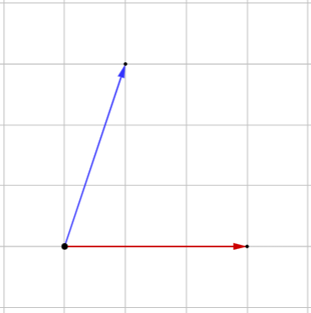  $\overset{̰}{u}⋅\overset{̰}{v}=$ …… | 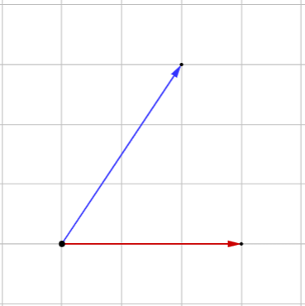  $\overset{̰}{u}⋅\overset{̰}{v}=$ ……
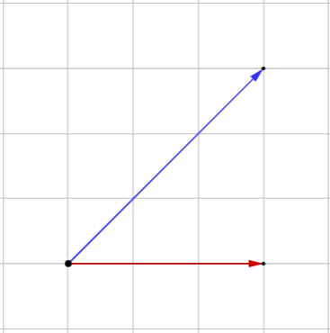  $\overset{̰}{u}⋅\overset{̰}{v}=$ …… | 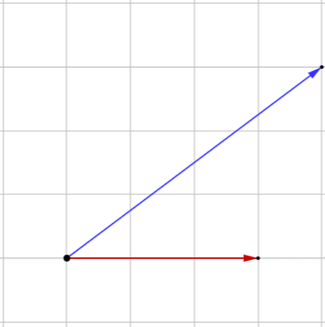  $\overset{̰}{u}⋅\overset{̰}{v}=$ …… | 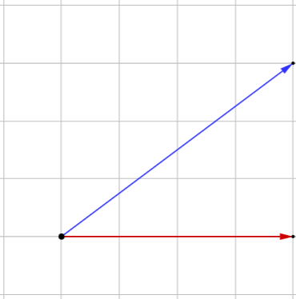  $\overset{̰}{u}⋅\overset{̰}{v}=$ ……
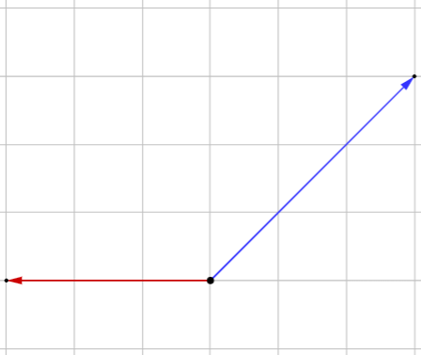  $\overset{̰}{u}⋅\overset{̰}{v}=$ …… | 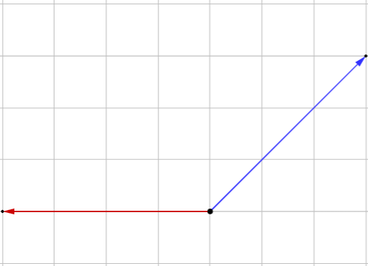  $\overset{̰}{u}⋅\overset{̰}{v}=$ …… | 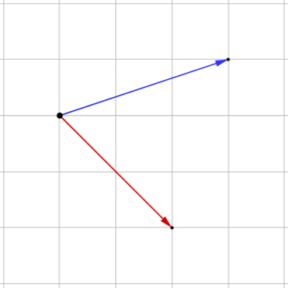  $\overset{̰}{u}⋅\overset{̰}{v}=$ ……
What do you think the dot product represents?
The dot product is how much of $\overset{̰}{a}$ points in the same …………… of $\overset{̰}{b}$, scaled by their ……………………

- Dot Product
The dot product multiplies two vectors to give a scalar.
This scalar measures how much the vectors point in the same direction, scaled by their magnitudes.
Algebraic Formula  For $\overset{̰}{a}=x_{1}i+y_{1}j$ and $\overset{̰}{b}=x_{2}i+y_{2}j:$  $$\overset{̰}{a}⋅\overset{̰}{b}=x_{1}x_{2}+y_{1}y_{2}$$ | Geometric Formula  For the angle $θ$ between two vectors $\overset{̰}{a}$ and $\overset{̰}{b}$:  $$\overset{̰}{a}⋅\overset{̰}{b}=\left|\overset{̰}{a}\right|\left|\overset{̰}{b}\right|\cos{θ}$$

- Dot Product Properties
Self-dot property: $\overset{̰}{a}⋅\overset{̰}{a}={\left|a\right|}^{2}$
Perpendicular vectors: $\overset{̰}{a}⋅\overset{̰}{b}=0$
Parallel vectors: $\overset{̰}{a}⋅\overset{̰}{b}=±\left|\overset{̰}{a}\right|\left|\overset{̰}{b}\right|$

- Proof of dot product properties
Let $\overset{̰}{a}=x_{1}i+y_{1}j$ and $\overset{̰}{b}=x_{2}i+y_{2}j$. Let $θ$ be the angle between them.
Prove $\overset{̰}{a}⋅\overset{̰}{a}={\left|\overset{̰}{a}\right|}^{2}$ using:
Algebraic formula  $$\overset{̰}{a}⋅\overset{̰}{a}=x_{1}x_{1}+y_{1}y_{1}$$  $=$ ………………  Using magnitude formula:  $$\left|\overset{̰}{a}\right|=\sqrt{ }$$ | Geometric formula  $$\overset{̰}{a}⋅\overset{̰}{a}=\left|\overset{̰}{a}\right|\left|\overset{̰}{a}\right|\cos{0°}$$
Prove $\overset{̰}{a}⋅\overset{̰}{b}=0$ for perpendicular vectors:
Reminder: Two vectors perpendicular when $\left(\begin{aligned}x_{1} \\ y_{1}\end{aligned}\right)⊥\left(\begin{aligned}-y_{1} \\ x_{1}\end{aligned}\right)$ and $θ=90°$
Algebraic formula  $$\overset{̰}{a}⋅\overset{̰}{b}=$$ | Geometric formula  $$\overset{̰}{a}⋅\overset{̰}{b}=$$

Prove $\overset{̰}{a}⋅\overset{̰}{b}=±\left|\overset{̰}{a}\right|\left|\overset{̰}{b}\right|$ for parallel vectors (use the geometric formula):
Reminder: Two vectors parallel when $θ=0°$ or $180°$
$$\overset{̰}{a}⋅\overset{̰}{b}=$$

- Proof of dot product formulae equivalence
We will now prove that $x_{1}x_{2}+y_{1}y_{2}=\left|\overset{̰}{a}\right|\left|\overset{̰}{b}\right|\cos{θ}$:

Let $\vec{OA}=\overset{̰}{a}$ and $\vec{OB}=\overset{̰}{b}$. Let $θ$ be the angle between them.
We will consider $A$ and $B$ to be in the first quadrant, for convenience.
All parts of this proof are valid for all quadrants.
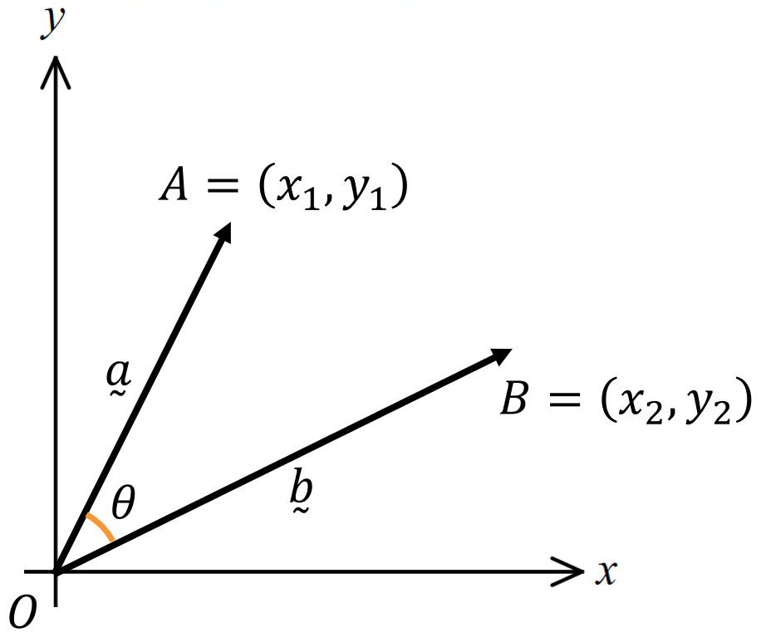
Construct the vector $\vec{AB}$ and write an expression for it
$\vec{AB}=$ $\vec{OB}$ $-$ …… $=$ $\overset{̰}{}-\overset{̰}{}$

Using Cosine rule, relate the three side lengths of the triangle.

${\left|\overset{̰}{b}-\overset{̰}{a}\right|}^{2}=$ ……………………………………

Use distance formula to expand ${\left|\overset{̰}{b}-\overset{̰}{a}\right|}^{2}={\left(x_{2}-x_{1}\right)}^{2}+{\left(y_{2}-y_{1}\right)}^{2},$ hence prove equivalence.

Foundation
- Find $\underset{∼}{u}·\underset{∼}{v}$ and hence determine in each part whether the vectors $\underset{∼}{u}$ and $\underset{∼}{v}$ are perpendicular.
- $\underset{∼}{u}= \left(\begin{aligned}-4 \\ 5\end{aligned}\right),\underset{∼}{v}= \left(\begin{aligned}7 \\ 6\end{aligned}\right)$  $$\overset{̰}{u}⋅\overset{̰}{v}=2$$  Not perpendicular | - $\underset{∼}{u}= \left(\begin{aligned}-4 \\ -6\end{aligned}\right),\underset{∼}{v}= \left(\begin{aligned}18 \\ -12\end{aligned}\right)$  $$\overset{̰}{u}⋅\overset{̰}{v}=0$$  perpendicular | - $\underset{∼}{u}= \left(\begin{aligned}-1 \\ a^{-2}\end{aligned}\right),\underset{∼}{v}= \left(\begin{aligned}a^{-1} \\ a\end{aligned}\right)$  $$\overset{̰}{u}⋅\overset{̰}{v}=0$$  perpendicular

- Show that $\underset{∼}{v}·\underset{∼}{v}= {\left|\underset{∼}{v}\right|}^{2}$ where:
- $\underset{∼}{v}= 3i - 4j$  $${\left|\underset{∼}{v}\right|}^{2}= 9 + 16 = 25$$  $$\underset{∼}{v}·\underset{∼}{v}= 3\left(3\right)+ \left(-4\right)\left(-4\right)= 9 + 16 = 25$$ | - $\underset{∼}{v}= ai + bj$  $${\left|\underset{∼}{v}\right|}^{2}= a^{2}+ b^{2}$$  $$\underset{∼}{v}·\underset{∼}{v}= a\left(a\right)+ b\left(b\right)= a^{2}+ b^{2}$$

- Suppose that A, B and C are the points (2, 5), (5, 14) and (−2, 13) respectively.
It is known that the angle between the vectors $\vec{AB}$ and $\vec{AC}$ is 45°.
  - Find the vectors $\vec{AB}$ and $\vec{AC}$ in component form.
$$\vec{AB} = \left(5-2, 14-5\right)= 3i + 9j$$
$$\vec{AC} = \left(-2-2, 13-5\right)= -4i + 8j$$
  - Find $\vec{AB} · \vec{AC}$ using the result $\underset{∼}{u}·\underset{∼}{v} = x₁x₂ + y₁y₂.$
$$3\left(-4\right)+ 9\left(8\right)= 60$$
  - Confirm your answer to part b using the result $\underset{∼}{u}·\underset{∼}{v}= \left|\underset{∼}{u}\right|\left|\underset{∼}{v}\right|cos θ.$
$$|\vec{AB}|= \sqrt{9 + 81}=\sqrt{90}$$
$$|\vec{AC}|= \sqrt{16 + 64}= \sqrt{80}$$
$$\left|\vec{AB}\right|\left|\vec{AC}\right| cos 45° = \sqrt{90}× \sqrt{80}× \left(\frac{1}{\sqrt{2}}\right) =60$$

- Suppose that P, Q and R are the points $\left(\sqrt{3}, 8\right), \left(3\sqrt{3}, 14\right)$and $\left(5\sqrt{3}, 12\right)$ respectively.
It is known that the angle between the vectors $\vec{PQ}$ and $\vec{PR}$ is 30°.
  - Find the vectors $\vec{PQ}$ and $\vec{PR}$ in component form.
$$\vec{PQ} = \left(3\sqrt{3}- \sqrt{3}, 14 - 8\right)= 2\sqrt{3}i+ 6j$$
$$\vec{PR} = \left(5\sqrt{3}- \sqrt{3}, 12 - 8\right)= 4\sqrt{3}i+ 4j$$
  - Find $\vec{PQ} · \vec{PR}$ using the result $\underset{∼}{u}·\underset{∼}{v} = x₁x₂ + y₁y₂.$

$$\left(2\sqrt{3}\right)\left(4\sqrt{3}\right)+ \left(6\right)\left(4\right)= 48$$
  - Confirm your answer to part b using the result $\underset{∼}{u}·\underset{∼}{v}= \left|\underset{∼}{u}\right|\left|\underset{∼}{v}\right|cos θ.$
$$\left|\vec{PQ}\right|= \sqrt{12 + 36}= \sqrt{48}$$
$$\left|\vec{PR}\right| = \sqrt{48 + 16}= 8$$
$$\left|\vec{PQ}\right|\left|\vec{PR}\right| cos 30° = \sqrt{48}× 8 × \left(\frac{\sqrt{3}}{2}\right)= 48$$

Development

  - Find the scalar product of $\underset{∼}{u}= 3i - 6j$ and $\underset{∼}{v} = -2i - j.$

$$\underset{∼}{u}·\underset{∼}{v}= 3\left(-2\right)+ \left(-6\right)\left(-1\right)= 0$$
  - Find the angle between the vectors.
θ = 90°

- Find the values of $λ$ for which the vectors $\underset{∼}{u}= λ^{2}i + 2j$ and $\underset{∼}{v}= 3i- \left(2 + 2λ\right)j$ are perpendicular.

$$\underset{∼}{u}·\underset{∼}{v}= 0 for perpendicular \\ λ^{2}\left(3\right)+ 2\left(-2 - 2λ\right)= 0 \\ 3λ² - 4 - 4λ = 0 \\ 3λ² - 4λ - 4 = 0 \\ (3λ + 2)(λ - 2) = 0 \\ λ = -\frac{2}{3}or 2$$

- The angle between vectors $\underset{∼}{u}= i-3j$ and $\underset{∼}{v}= ai + 5j$ is 120°.
Evaluate $a$ correct to 1 decimal place.

$$\underset{∼}{u}·\underset{∼}{v}= a - 15 \\ \left|\underset{∼}{u}\right|= \sqrt{10}, \left|\underset{∼}{v}\right|= \sqrt{a^{2}+ 25} \\ cos 120° =\frac{a - 15}{\sqrt{10}× \sqrt{a^{2}+ 25}} \\ -\frac{1}{2}=\frac{a - 15}{\sqrt{10\left(a^{2}+ 25\right)}} \\ -\sqrt{10\left(a^{2}+ 25\right)}= 2\left(a - 15\right) \\ 10(a² + 25) = 4{\left(a - 15\right)}^{2} \\ 10a^{2}+ 250 = 4a^{2}- 120a + 900 \\ 6a^{2}+ 120a - 650 = 0 \\ 3a^{2}+ 60a - 325 = 0 \\ a =\frac{-60 ± \sqrt{3600 + 3900}}{6}=\frac{-60 ± \sqrt{7500}}{6} \\ a≈ 4.4 or -24.4$$

- A question in the textbook says:
‘Find vector $\underset{∼}{b}$ given $\underset{∼}{a}= 3i - j, \underset{∼}{a}·\underset{∼}{b}= -6$ and the angle between $\underset{∼}{a}$ and $\underset{∼}{b}$ is 30°’
Explain why there must be a typo in this question.

$$\overset{̰}{a}⋅\overset{̰}{b}=\left|\overset{̰}{a}\right|\left|\overset{̰}{b}\right|\cos{θ}$$
For this expression to be negative, $\cos{θ}$must be negative, so $θ$ cannot be acute.
If the dot product is negative, the angle between the vectors must be obtuse.

Proofs using Vectors

- Proofs using Vectors
We can use vectors and the dot product to prove many geometrical properties.

Triangle Addition Law: $\vec{AB}+\vec{BC}=\vec{AC}$
Parallelogram Subtraction Law: $\vec{AB}-\vec{AD}=\vec{DB}$

Two vectors $\overset{̰}{a}$ and $\overset{̰}{b}$ parallel when: $\overset{̰}{b}=λ\overset{̰}{a}, λ∈R$
A, B, C are collinear if $\vec{AB}$ and $\vec{BC}$ are parallel.
Dot Product Algebraic Formula  For $\overset{̰}{a}=x_{1}i+y_{1}j$ and $\overset{̰}{b}=x_{2}i+y_{2}j:$  $$\overset{̰}{a}⋅\overset{̰}{b}=x_{1}x_{2}+y_{1}y_{2}$$ | Dot Product Geometric Formula  For the angle $θ$ between two vectors $\overset{̰}{a}$ and $\overset{̰}{b}$:  $$\overset{̰}{a}⋅\overset{̰}{b}=\left|\overset{̰}{a}\right|\left|\overset{̰}{b}\right|\cos{θ}$$
Self-dot property: $\overset{̰}{a}⋅\overset{̰}{a}={\left|a\right|}^{2}$
Perpendicular vectors: $\overset{̰}{a}⋅\overset{̰}{b}=0$
Parallel vectors: $\overset{̰}{a}⋅\overset{̰}{b}=±\left|\overset{̰}{a}\right|\left|\overset{̰}{b}\right|$

Foundation
- The quadrilateral ABCD has vertices A$\left(-3, -6\right), B\left(1, -4\right), C\left(-2, 2\right)$ and $D\left(-6, 0\right).$
  - Show that $\vec{AB} = \vec{DC}$and $\vec{AD}=\vec{BC}$.

$$\vec{AB} = \vec{OB}-\vec{OA}=(1-(-3), -4-(-6)) = \left(4, 2\right) \\ \vec{DC} = (-2-(-6), 2-0) = \left(4, 2\right) \\ ∴ \vec{AB} = \vec{DC}$$
Similarly, $\vec{AD}=\vec{BC}=(-3,6)$
  - Show that$\vec{AB} · \vec{AD} = 0$.

$$\vec{AB} · \vec{AD} = 4\left(-3\right)+ 2\left(6\right)= -12 + 12 = 0$$
  - What type of special quadrilateral is $ABCD$? Give reasons for your answer.

Rectangle: parallelogram (opposite sides equal) with adjacent sides perpendicular (not a square as magnitudes of sides not equal).
- The quadrilateral PQRS has vertices $P\left(-8, 3\right), Q\left(3, 7\right), R\left(7, 18\right)$ and $S\left(-4, 14\right).$
  - Show that the diagonals PR and QS bisect each other by showing $½\vec{PR} = \vec{PQ} + ½\vec{QS}$

$$\vec{PR} = (7-(-8), 18-3) = (15, 15) \\ ½\vec{PR} = (7.5, 7.5) \\ \vec{PQ} = (3-(-8), 7-3) = (11, 4) \\ \vec{QS} = (-4-3, 14-7) = (-7, 7) \\ ½\vec{QS} = (-3.5, 3.5) \\ \vec{PQ} + ½\vec{QS} = (11-3.5, 4+3.5) = (7.5, 7.5) = ½\vec{PR}$$
  - Show that that the diagonals are perpendicular by showing that $\vec{PR} · \vec{QS} = 0$.

$$\vec{PR} · \vec{QS} = 15\left(-7\right)+ 15\left(7\right)= 0$$
  - What type of special quadrilateral is PQRS? Give reasons for your answer.

Rhombus: diagonals bisect each other at 90°

- Suppose that A, P and Q are the points (−3, 3), (2, 9) and (10, 0) respectively.
  - Write $\vec{AP}$ and $\vec{AQ}$ as column vectors.

$$\vec{AP} = \left(2-\left(-3\right), 9-3\right)= \left(\begin{aligned}5 \\ 6\end{aligned}\right)$$
$$\vec{AQ} = \left(10-\left(-3\right), 0-3\right)= \left(\begin{aligned}13 \\ -3\end{aligned}\right)$$
  - Hence find ∠PAQ correct to the nearest degree.
$$\vec{AP} · \vec{AQ} = 5(13) + 6(-3) = 47 \\ \left|\vec{AP}\right|= \sqrt{25 + 36}= \sqrt{61} \\ \left|\vec{AQ}\right|= \sqrt{169 + 9}= \sqrt{178} \\ cos θ =\frac{47}{\sqrt{61 × 178}}=\frac{47}{\sqrt{10858}} \\ θ = cos^{-1}\left(\frac{47}{\sqrt{10858}}\right)≈ 63°$$
- The quadrilateral PQRS has vertices P(1, 2), Q(8, 3), R(6, 13) and S(4, 9). Use the dot product to find, correct to the nearest minute, the acute angle between the diagonals.

$$\vec{PR} = (5, 11), \vec{QS} = \left(-4, 6\right) \\ \vec{PR} · \vec{QS} = -20 + 66 = 46 \\ \left|\vec{PR}\right|= \sqrt{146}, \left|\vec{QS}\right|= \sqrt{52} \\ cos θ =\frac{46}{\sqrt{146 × 52}}=\frac{46}{\sqrt{7592}} \\ θ≈ 58°8'$$

- Given $\vec{OA} = \left(\begin{aligned}6 \\ 2\end{aligned}\right)$ and $\vec{OB} = \left(\begin{aligned}1 \\ 5\end{aligned}\right)$:
  - Find the angle in degrees and minutes, to the nearest minute, between:
- $\vec{OA} and \vec{OB}$  $$\vec{OA} · \vec{OB} = 6\left(1\right)+ 2\left(5\right)= 16 \\ \left|\vec{OA}\right|= \sqrt{40}, \left|\vec{OB}\right|= \sqrt{26} \\ cos θ =\frac{16}{\sqrt{1040}} \\ θ≈ 60°15'$$ | - $\vec{OA} and \vec{OA} - \vec{OB}$  $$\vec{OA} - \vec{OB} = \left(5, -3\right) \\ \vec{OA} · \left(\vec{OA} - \vec{OB}\right)= 6\left(5\right)+ 2\left(-3\right)= 24 \\ \left|\vec{OA} - \vec{OB}\right|= \sqrt{34} \\ cos θ =\frac{24}{\sqrt{40}× \sqrt{34}} \\ θ ≈ 49°24'$$ | - $\vec{OB} and \vec{OA} - \vec{OB}$  $$\vec{OB} · \left(\vec{OA} - \vec{OB}\right)= 1\left(5\right)+ 5\left(-3\right)= -10 \\ cos θ = -\frac{10}{\sqrt{26}× \sqrt{34}} \\ θ≈ 109°{39}^{'}$$

  - What geometrical relationship does this illustrate?
A sketch is useful here.
Exterior angle of triangle = sum of interior opposite angles
109°39′ = 60°15′ + 49°24′

- The point $P\left(r cos θ, r sin θ\right)$ varies on the circle $x² + y² = r².$
Let A and B be the points $(-r, 0)$and $(r, 0)$ respectively.
Use the dot product to show that ∠APB = 90°, provided that P ≠ A or B.

$$\vec{AP} = (r cos θ - (-r), r sin θ) = (r cos θ + r, r sin θ) \\ \vec{BP} = (r cos θ - r, r sin θ) \\ \vec{AP} · \vec{BP} = (r cos θ + r)(r cos θ - r) + r² sin² θ \\ = r² cos² θ - r² + r² sin² θ \\ = r²(cos² θ + sin² θ) - r² \\ = r² - r² = 0 \\ ∴ ∠APB = 90°$$

Development
- Triangle ABC has vertices A(2, 1), B(10, 4) and C(5, 13).
  - Show that $cos ∠ABC =$ $\frac{13}{\sqrt{7738}}$
$$\vec{BA} = (2-10, 1-4) = (-8, -3) \\ \vec{BC} = (5-10, 13-4) = (-5, 9) \\ \vec{BA} · \vec{BC} = 40 - 27 = 13 \\ \left|\vec{BA}\right|= \sqrt{64 + 9}= \sqrt{73} \\ \left|\vec{BC}\right|= \sqrt{25 + 81}= \sqrt{106} \\ cos ∠ABC =\frac{13}{\sqrt{73 × 106}}=\frac{13}{\sqrt{7738}}$$

  - Find the exact value of $sin ∠ABC$.
$$using\sin^{2}{x}+\cos^{2}{x}=1 \\ \sin^{2}∠ABC = 1 -\frac{169}{7738} \\ =\frac{7569}{7738} \\ sin ∠ABC =\frac{87}{\sqrt{7738}}$$
  - Hence find the area of triangle ABC.
$$Area = ½ × \left|\vec{BA}\right|× \left|\vec{BC}\right|×\sin{∠ABC} \\ = ½ × \sqrt{73}× \sqrt{106}×\frac{87}{\sqrt{7738}} \\ = ½ × 87 \\ = 43.5 u²$$

- In $△ABC$ to the right, $P$ is the midpoint of $AC$ and $Q$ is the midpoint of $BC$.
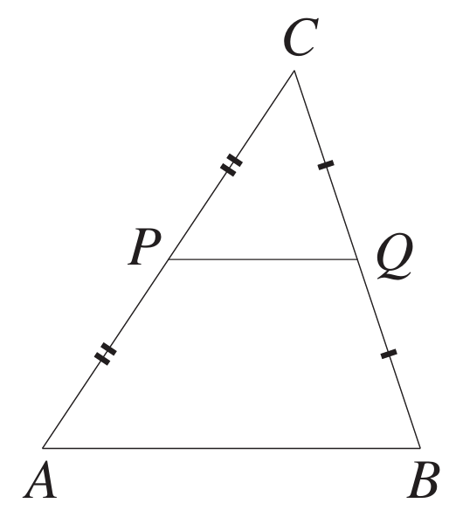
Let $\vec{AC} =\underset{∼}{a}$ and $\vec{CB} =\underset{∼}{b}$.
  - Write $\vec{AB}$ in terms of $\underset{∼}{a}$ and $\underset{∼}{b}.$
  - Write $\vec{PQ}$ in terms of $\underset{∼}{a}$ and $\underset{∼}{b}.$
  - Hence explain why $\vec{PQ}$ is parallel to $\vec{AB}$ and half its length.
$$1a$$
$$\vec{AC} =\underset{∼}{a} and \vec{CB} =\underset{∼}{b} \\ P is the midpoint of AC and Q is the midpoint of BC \\ Hence, AP = PC and QC = QB \\ \vec{AB} = \vec{AC} + \vec{CB} \\ =\underset{∼}{a}+\underset{∼}{b}$$
$$1b$$
$$\vec{PC} =\frac{1}{2}\vec{AC} =\frac{1}{2}\underset{∼}{a} \\ \vec{CQ} =\frac{1}{2}\vec{CB} =\frac{1}{2}\underset{∼}{b} \\ \vec{PQ} = \vec{PC} + \vec{CQ} \\ =\left(\frac{1}{2}\right)\underset{∼}{a}+\left(\frac{1}{2}\right)\underset{∼}{b} \\ =\frac{1}{2}\left(\underset{∼}{a}+\underset{∼}{b}\right)$$

$$1c$$
$$\vec{PQ} =\frac{1}{2}\left(\underset{∼}{a}+\underset{∼}{b}\right)=\frac{1}{2}\vec{AB} \\ Hence, PQ ∥ AB and PQ =\frac{1}{2}AB.$$
- In the diagram to the right, $ABCD$ is a quadrilateral.
The points $P, Q, R$ and $S$ are the midpoints of $AB, BC, CD$ and $DA$ respectively.
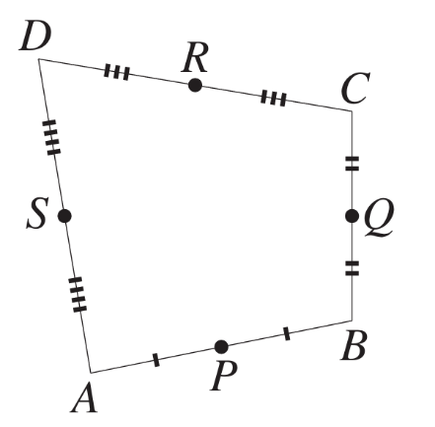
Let$\vec{AB} =\underset{∼}{a}, \vec{BC} =\underset{∼}{b}, \vec{AD} =\underset{∼}{d}$and $\vec{DC} =\underset{∼}{c}.$
  - Explain why $\underset{∼}{a}+\underset{∼}{b}=\underset{∼}{d}+\underset{∼}{c}$.
  - Express $\vec{PQ}$ in terms of $\underset{∼}{a}$ and $\underset{∼}{b}.$
  - Express $\vec{SR}$ in terms of $\underset{∼}{d}$ and $\underset{∼}{c}$.
  - Hence show that $\vec{PQ} = \vec{SR}$.
  - Deduce that the quadrilateral $PQRS$ is a parallelogram.
$$a$$
$$\vec{AB} =\underset{∼}{a}, \vec{BC} =\underset{∼}{b}, \vec{AD} =\underset{∼}{d} and \vec{DC} =\underset{∼}{c} \\ \vec{AB} + \vec{BC} = \vec{AC} =\underset{∼}{a}+\underset{∼}{b} \\ \vec{AD} + \vec{DC} = \vec{AC} =\underset{∼}{d}+\underset{∼}{c} \\ As \vec{AB} + \vec{BC} = \vec{AC} = \vec{AD} + \vec{DC} \\ Hence, \vec{AC} =\underset{∼}{a}+\underset{∼}{b}=\underset{∼}{d}+\underset{∼}{c}.$$

$$b$$
$$P is the midpoint of AB and Q is the midpoint of BC.$$
$$Hence, AP = PB and BQ = QC.$$
$$\vec{PB} =\frac{1}{2}\vec{AB} =\frac{1}{2}\underset{∼}{a} \\ \vec{BQ} =\frac{1}{2}\vec{BC} =\frac{1}{2}\underset{∼}{b} \\ \vec{PQ} = \vec{PB} + \vec{BQ} \\ =\frac{1}{2}\underset{∼}{a}+\frac{1}{2}\underset{∼}{b} \\ =\frac{1}{2}\left(\underset{∼}{a}+\underset{∼}{b}\right)$$

$$c$$
$$R is the midpoint of CD and S is the midpoint of DA.$$
$$Hence, AS = SD and DR = RC$$
$$\vec{DR} =\frac{1}{2}\vec{DC} =\frac{1}{2}\underset{∼}{c} \\ \vec{SD} =\frac{1}{2}\vec{AD} =\frac{1}{2}\underset{∼}{d} \\ \vec{SR} = \vec{SD} + \vec{DR} \\ =\frac{1}{2}\underset{∼}{d}+\frac{1}{2}\underset{∼}{c} \\ =\frac{1}{2}\left(\underset{∼}{d}+\underset{∼}{c}\right)$$

$$d$$
$$From part a, \vec{AC} =\underset{∼}{a}+\underset{∼}{b}=\underset{∼}{d}+\underset{∼}{c}$$
$$\vec{PQ} =\frac{1}{2}\left(\underset{∼}{a}+\underset{∼}{b}\right)=\frac{1}{2}\vec{AC} \\ \vec{SR} =\frac{1}{2}\left(\underset{∼}{d}+\underset{∼}{c}\right)=\frac{1}{2}\vec{AC} \\ Hence, \vec{PQ} = \vec{SR}.$$

$$e$$
$$Since \vec{PQ} = \vec{SR},$$
$$the line joining midpoints of the adjacent sides of the quadrilateral are parallel and equal to each other,$$
$$hence, ABCD is a parallelogram.$$
- The rectangle $ABCD$ to the right has side lengths $|AB| = x$ and $|BC| = y$.
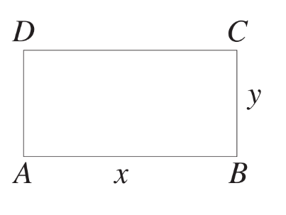
Let $\vec{AB} =\underset{∼}{a}, \vec{BC} =\underset{∼}{b}$ and $\vec{CD} =\underset{∼}{c} .$
  - Express $\vec{AC}$ in terms of $\underset{∼}{a}$ and $\underset{∼}{b},$ and $\vec{BD}$ in terms of $\underset{∼}{b}$ and $\underset{∼}{c}.$
  - What is the value of $\underset{∼}{a}·\underset{∼}{b}?$
  - Write $\underset{∼}{a}·\underset{∼}{a}$ in terms of $x$.
  - Show that $\left(\underset{∼}{a}+\underset{∼}{b}\right)· \left(\underset{∼}{a}+\underset{∼}{b}\right)$ and $\left(\underset{∼}{b}+\underset{∼}{c}\right)· \left(\underset{∼}{b}+\underset{∼}{c}\right)$
are both equal to $x² + y².$
  - What have we proven in part d about the diagonals of a rectangle?

$$a$$
$$\vec{AB} =\underset{∼}{a}, \vec{BC} =\underset{∼}{b} and \vec{CD} =\underset{∼}{c} \\ \vec{AC} = \vec{AB} + \vec{BC} \\ =\underset{∼}{a}+\underset{∼}{b} \\ \vec{BD} = \vec{BC} + \vec{CD} \\ =\underset{∼}{b}+\underset{∼}{c}$$

$$b$$
$$\underset{∼}{a}·\underset{∼}{b}= \left|\underset{∼}{a}\right|\left|\underset{∼}{b}\right|cos θ \\ θ is the angle between \underset{∼}{a} and\underset{∼}{b}. \\ ABCD is a rectangle hence, θ = 90°. \\ \left|\underset{∼}{a}\right|= x and \left|\underset{∼}{b}\right|= y \\ \underset{∼}{a}·\underset{∼}{b}= x × y × cos 90° \\ = 0$$

$$c$$
$$\underset{∼}{a}·\underset{∼}{a}= {\left|\underset{∼}{a}\right|}^{2}= x^{2}$$

$$d$$
$${\left|\underset{∼}{a}+\underset{∼}{b}\right|}^{2}= {\left|\vec{AC}\right|}^{2}= x^{2}+ y^{2} \\ |\vec{AC}| = \sqrt{x^{2}+ y^{2}} \\ (a┬∼ + b┬∼) · (a┬∼ + b┬∼) \\ = |a┬∼ + b┬∼||a┬∼ + b┬∼| cos θ \\ = \sqrt{x^{2}+ y^{2}}× \sqrt{x^{2}+ y^{2}}× cos 0° \\ = (x² + y²) × 1 \\ = x^{2}+ y^{2}$$

$${\left|\underset{∼}{b}+\underset{∼}{c}\right|}^{2} = |\vec{BD}|² = x² + y² \\ As ABCD is a rectangle, |\vec{AB}| = |\vec{CD}|. \\ |\vec{BD}| = \sqrt{x^{2}+ y^{2}} \\ \left(\underset{∼}{b}+\underset{∼}{c}\right)· \left(\underset{∼}{b}+\underset{∼}{c}\right) \\ = \left|\underset{∼}{b}+\underset{∼}{c}\right|\left|\underset{∼}{b}+\underset{∼}{c}\right|cos θ \\ = \sqrt{x^{2}+ y^{2}}× \sqrt{x^{2}+ y^{2}}× cos 0° \\ = (x² + y²) × 1 \\ = x^{2}+ y^{2}$$

$$e$$
$$The diagonals of a rectangle have equal length.$$
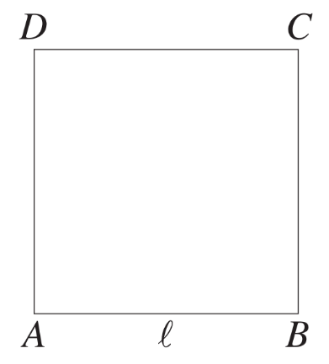
- The square ABCD to the right has side length $l$.
Let $\vec{AB} =\underset{∼}{a}$ and $\vec{BC} =\underset{∼}{b}$.
  - Express $\vec{AC}$ and $\vec{BD}$ in terms of $\underset{∼}{a}$ and $\underset{∼}{b}$.
  - What is the value of $\underset{∼}{a}·\underset{∼}{b}$?
  - Write $\underset{∼}{a}·\underset{∼}{a}$ in terms of $l$.
  - Find $\left(\underset{∼}{a}+\underset{∼}{b}\right)· \left(\underset{∼}{b}-\underset{∼}{a}\right).$
  - What have we proven in part d about the diagonals of a square?

$$a$$
$$\vec{AB} =\underset{∼}{a} and \vec{BC} =\underset{∼}{b} \\ \vec{AC} = \vec{AB} + \vec{BC} \\ =\underset{∼}{a}+\underset{∼}{b} \\ \vec{BD} = \vec{AD} - \vec{AB} \\ =\underset{∼}{b}-\underset{∼}{a}$$

$$b$$
$$\underset{∼}{a}·\underset{∼}{b}= \left|\underset{∼}{a}\right|\left|\underset{∼}{b}\right|cos θ \\ θ is the angle between \underset{∼}{a} and \underset{∼}{b}. \\ ABCD is a square hence, θ = 90°. \\ \left|\underset{∼}{a}\right|= l and \left|\underset{∼}{b}\right|= l \\ \underset{∼}{a}·\underset{∼}{b}= l × l × cos 90° \\ = 0$$

$$c$$
$$\underset{∼}{a}·\underset{∼}{a}= {\left|\underset{∼}{a}\right|}^{2}= l^{2}$$

$$d$$
$${\left|\underset{∼}{a}+\underset{∼}{b}\right|}^{2}= {\left|\vec{AC}\right|}^{2}= l^{2}+ l^{2}= 2l^{2} \\ \left|\vec{AC}\right|= \sqrt{2l^{2}}= \sqrt{2}l \\ {\left|\underset{∼}{b}-\underset{∼}{a}\right|}^{2}= {\left|\vec{BD}\right|}^{2}= l^{2}+ l^{2} \\ \left|\vec{BD}\right|= \sqrt{2l^{2}}= \sqrt{2}l$$

$$\left(\underset{∼}{a}+\underset{∼}{b}\right)· \left(\underset{∼}{b}-\underset{∼}{a}\right) \\ = |a┬∼ + b┬∼||b┬∼ - a┬∼| cos θ \\ = √2 l × √2 l × cos 90° \\ = 2l² × 0 \\ = 0$$

e
The diagonals of the square meet at right angles.

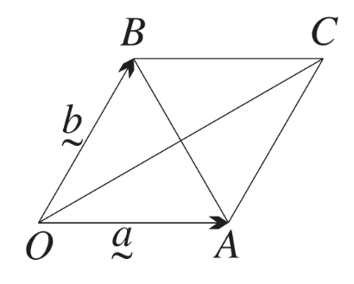
- In the diagram to the right, $OACB$ is a rhombus.
Let $\vec{OA} =\underset{∼}{a}$ and $\vec{OB} =\underset{∼}{b}$.
  - Why is $\left|\underset{∼}{a}\right|= \left|\underset{∼}{b}\right|?$
  - By squaring the result in part a, show that $\underset{∼}{a}·\underset{∼}{a}=\underset{∼}{b}·\underset{∼}{b} .$
  - Express $\vec{OC}$ and $\vec{BA}$in terms of $\underset{∼}{a}$ and $\underset{∼}{b}$.
  - Hence show that $\vec{OC} · \vec{BA} = 0$.
  - What have we just proven about the diagonals of a rhombus?

$$a$$
$$\vec{OA} =\underset{∼}{a} and \vec{OB} =\underset{∼}{b}$$
$$\left|\underset{∼}{a}\right|= \left|\underset{∼}{b}\right|because the sides of rhombus are equal.$$

$$b$$
$$\underset{∼}{a}·\underset{∼}{a}= {\left|\underset{∼}{a}\right|}^{2} \\ \underset{∼}{b}·\underset{∼}{b}= {\left|\underset{∼}{b}\right|}^{2}= {\left|\underset{∼}{a}\right|}^{2}as \left|\underset{∼}{a}\right|= \left|\underset{∼}{b}\right| \\ Hence,\underset{∼}{a}·\underset{∼}{a}=\underset{∼}{b}·\underset{∼}{b}.$$

$$c$$
$$\vec{OC} = \vec{OB} + \vec{BC} \\ = \vec{OB} + \vec{OA} \\ =\underset{∼}{b}+\underset{∼}{a} \\ =\underset{∼}{a}+\underset{∼}{b} \\ \vec{BA} = \vec{BO} + \vec{OA} \\ = \vec{OA} - \vec{OB} \\ =\underset{∼}{a}-\underset{∼}{b}$$

$$d$$
$$\vec{OC} · \vec{BA}= \left(\underset{∼}{a}+\underset{∼}{b}\right)· \left(\underset{∼}{a}-\underset{∼}{b}\right) \\ = {\left|\underset{∼}{a}\right|}^{2}- {\left|\underset{∼}{b}\right|}^{2} \\ = {\left|\underset{∼}{a}\right|}^{2}- {\left|\underset{∼}{a}\right|}^{2}, as \left|\underset{∼}{a}\right|= \left|\underset{∼}{b}\right| \\ = 0$$

e
Diagonals of a rhombus are perpendicular.

Mastery
- In the diagram to the right, $OABC$ is a parallelogram whose diagonals $OB$ and $AC$ are equal.
The points A and C have respective position vectors $\underset{∼}{a}$ and $\underset{∼}{c}$ relative to O.
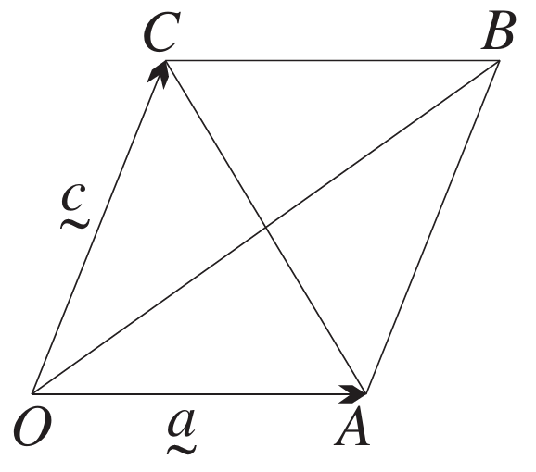
  - Explain why $\vec{CB} =\underset{∼}{a}.$
  - Write $\vec{OB}$ in terms of $\underset{∼}{c}$ and $\underset{∼}{a}.$
  - Write $\vec{AC}$ in terms of $\underset{∼}{c}$ and $\underset{∼}{a}.$
  - Explain why $\left|\underset{∼}{c}+\underset{∼}{a}\right|= \left|\underset{∼}{c}-\underset{∼}{a}\right|.$
  - Use the result in part d, and the fact that ${\left|\underset{∼}{v}\right|}^{2}=\underset{∼}{v}·\underset{∼}{v},$
to show that $\underset{∼}{a}·\underset{∼}{c}= 0$.
  - What can we now say about a parallelogram whose diagonals are equal?

$$a$$
$$The opposite sides of a parallelogram are equal, hence \vec{CB} =\underset{∼}{a}.$$

$$b$$
$$\vec{OB} = \vec{OC} + \vec{CB} \\ =\underset{∼}{c}+\underset{∼}{a}$$

$$c$$
$$\vec{AC} = \vec{AB} + \vec{BC} \\ = \vec{OC} - \vec{CB} \\ =\underset{∼}{c}-\underset{∼}{a}$$

$$d$$
$$\left|\underset{∼}{c}+\underset{∼}{a}\right|= \left|\underset{∼}{c}-\underset{∼}{a}\right|because \left|\vec{OB}\right|= \left|\vec{AC}\right| \left(diagonals of this parallelogram are equal\right).$$

$$e$$
$$Since \left|\underset{∼}{c}+\underset{∼}{a}\right|= \left|\underset{∼}{c}-\underset{∼}{a}\right|, \\ {\left|\underset{∼}{c}+\underset{∼}{a}\right|}^{2}= {\left|\underset{∼}{c}-\underset{∼}{a}\right|}^{2} \\ {\left|\underset{∼}{c}+\underset{∼}{a}\right|}^{2}- {\left|\underset{∼}{c}-\underset{∼}{a}\right|}^{2}= 0 \\ \left(\underset{∼}{c}+\underset{∼}{a}\right)· \left(\underset{∼}{c}+\underset{∼}{a}\right)- \left(\underset{∼}{c}-\underset{∼}{a}\right)· \left(\underset{∼}{c}-\underset{∼}{a}\right)= 0 \\ \underset{∼}{c}·\underset{∼}{c}+ 2\left(\underset{∼}{a}·\underset{∼}{c}\right)+\underset{∼}{a}·\underset{∼}{a}- \left(\underset{∼}{c}·\underset{∼}{c}- 2\left(\underset{∼}{a}·\underset{∼}{c}\right)+\underset{∼}{a}·\underset{∼}{a}\right)= 0 \\ {\left|\underset{∼}{c}\right|}^{2}+ 2\left(\underset{∼}{a}·\underset{∼}{c}\right)+ {\left|\underset{∼}{a}\right|}^{2}- {\left|\underset{∼}{c}\right|}^{2}+ 2\left(\underset{∼}{a}·\underset{∼}{c}\right)- {\left|\underset{∼}{a}\right|}^{2}= 0 \\ 4\left(\underset{∼}{a}·\underset{∼}{c}\right)= 0 \\ \underset{∼}{a}·\underset{∼}{c}= 0$$

$$f$$
$$It is a rectangle as \underset{∼}{a}·\underset{∼}{c}= 0$$

- In the diagram, $O$ is the centre of a semi-circle $APB$ whose diameter is $AB$.
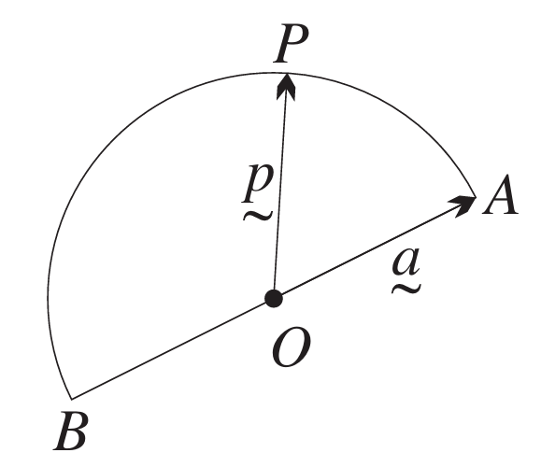
Let $\vec{OA} =\underset{∼}{a}$ and $\vec{OP} =\underset{∼}{p}.$
  - Write $\vec{OB}$ in terms of $\underset{∼}{a}$.
  - Express $\vec{AP}$ and $\vec{BP}$ in terms of $\underset{∼}{a}$ and $\underset{∼}{p}.$
  - Hence prove that $∠APB = 90°$.
  - What circle geometry theorem have we just proven?

$$a$$
$$\vec{OA} =\underset{∼}{a} and \vec{OP} =\underset{∼}{p}$$
$$Since \vec{AB} is the diameter and \vec{OB} is the radius in the opposite direction to \vec{OA},$$
$$\vec{OB} = -\underset{∼}{a}$$

$$b$$
$$\vec{AP} = \vec{AO} + \vec{OP} \\ = \vec{OP} - \vec{OA} \\ =\underset{∼}{p}-\underset{∼}{a} \\ \vec{BP} = \vec{BO} + \vec{OP} \\ = \vec{OP} - \vec{OB} \\ =\underset{∼}{p}- \left(-\underset{∼}{a}\right) \\ =\underset{∼}{p}+\underset{∼}{a}$$

$$c$$
$$\vec{AP} · \vec{BP} = \left(\underset{∼}{p}-\underset{∼}{a}\right)· \left(\underset{∼}{p}+\underset{∼}{a}\right) \\ =\underset{∼}{p}·\underset{∼}{p}+\underset{∼}{p}·\underset{∼}{a}-\underset{∼}{a}·\underset{∼}{p}-\underset{∼}{a}·\underset{∼}{a} \\ =\underset{∼}{p}·\underset{∼}{p}-\underset{∼}{a}·\underset{∼}{a} \\ = {\left|\underset{∼}{p}\right|}^{2}- {\left|\underset{∼}{a}\right|}^{2} \\ = {\left|\underset{∼}{p}\right|}^{2}- {\left|\underset{∼}{p}\right|}^{2} \left(since \vec{OA} and \vec{OP} are radii and hence \left|\underset{∼}{a}\right|= \left|\underset{∼}{p}\right|\right) \\ = 0$$
$$Therefore, \vec{AP} and \vec{BP} are perpendicular. Hence, ∠APB = 90°.$$

$$d$$
$$An angle in a semicircle is a right angle.$$

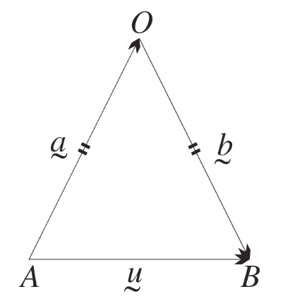
- Prove that the base angles of an isosceles triangle are equal.

$$Let △OAB be isosceles with OA = OB. \\ Let \underset{∼}{a} = \vec{AO} and \underset{∼}{b} = \vec{OB} and \vec{AB} =\underset{∼}{u} . \\ Then \underset{∼}{u}=\underset{∼}{a}+\underset{∼}{b}, so using the geometric dot product formula, \\ \left|\underset{∼}{a}\right|\left|\underset{∼}{u}\right|cos A =\underset{∼}{a}·\underset{∼}{u}=\underset{∼}{a}· \left(\underset{∼}{a}+\underset{∼}{b}\right)=\underset{∼}{a}·\underset{∼}{a}+\underset{∼}{a}·\underset{∼}{b} \\ \left|\underset{∼}{b}\right|\left|\underset{∼}{u}\right|cos B =\underset{∼}{b}·\underset{∼}{u}=\underset{∼}{b}· \left(\underset{∼}{a}+\underset{∼}{b}\right)=\underset{∼}{b}·\underset{∼}{a}+\underset{∼}{b}·\underset{∼}{b} \\ Subtracting, and using the fact that \left|\underset{∼}{b}\right|= \left|\underset{∼}{a}\right|, and so also that \underset{∼}{a}·\underset{∼}{a}=\underset{∼}{b}·\underset{∼}{b}, \\ \left|\underset{∼}{u}\right|\left|\underset{∼}{a}\right|\left(cos A - cos B\right)= 0. \\ Hence cos A = cos B, so A = B because cosine is one to one in the interval [0, π].$$

- Prove, using vectors, that the diagonals of a parallelogram bisect each other.
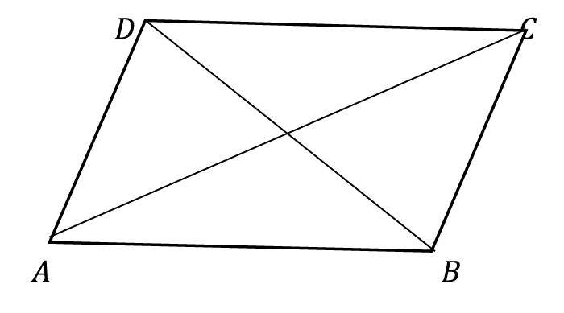
$$Let ABCD be a parallelogram.$$
$$Let \underset{∼}{a},\underset{∼}{b},\underset{∼}{c} and \underset{∼}{d} be the respective position vectors of A, B, C and D relative to an origin O.$$
$$As ABCD is a parallelogram, then opposite sides of the parallelogram are equal.$$
$$\vec{AB} = \vec{DC}$$
$$\vec{OB} - \vec{OA} = \vec{OC} - \vec{OD}$$
$$\underset{∼}{b}-\underset{∼}{a}=\underset{∼}{c}-\underset{∼}{d}$$
$$\underset{∼}{b}+\underset{∼}{d}=\underset{∼}{a}+\underset{∼}{c}$$
$$We can also write,$$
$$\frac{1}{2}\left(\underset{∼}{b}+\underset{∼}{d}\right)=\frac{1}{2}\left(\underset{∼}{a}+\underset{∼}{c}\right)$$
$$\frac{1}{2}\left(\vec{OB} + \vec{OD}\right)=\frac{1}{2}\left(\vec{OA} + \vec{OC}\right)$$
$$\frac{1}{2}\vec{BD} =\frac{1}{2}\vec{AC}$$
$$\vec{BD} and \vec{AC} are the diagonals of the parallelogram.$$
$$Hence, this shows that the diagonals of the parallelogram bisect each other.$$

Vector Projection

- Interpret horizontal and vertical projection
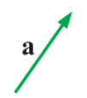
Consider the vector $\overset{̰}{a}$.

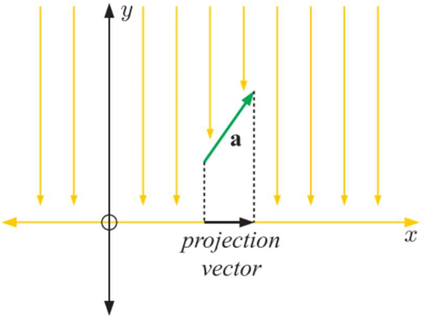 | If a light shines directly down onto vector $\overset{̰}{a}$, the ……………… it casts on the $x$-axis is called the horizontal ……………… of $\overset{̰}{a}$.  This is also called the projection of …… onto …….  This is also the horizontal component of $\overset{̰}{a}$.
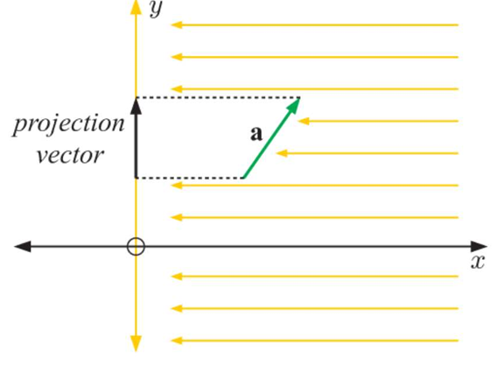 | If a light shines sideways onto vector $\overset{̰}{a}$, the shadow it casts on the …… axis is called the …………… projection of $\overset{̰}{a}$.  This is also called the projection of …… onto …….  This is also the …………… vertical of $\overset{̰}{a}$.

Sketch these projections. The first has been done for you.

- Vertical projection  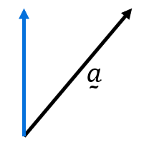 | - Horizontal projection  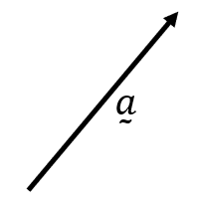 | 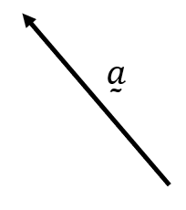  - Horizontal projection
- Vertical projection | - Vertical projection  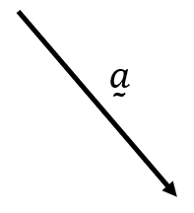 | - Horizontal projection

- Interpret vector projection
Consider the vector $\overset{̰}{a}$.

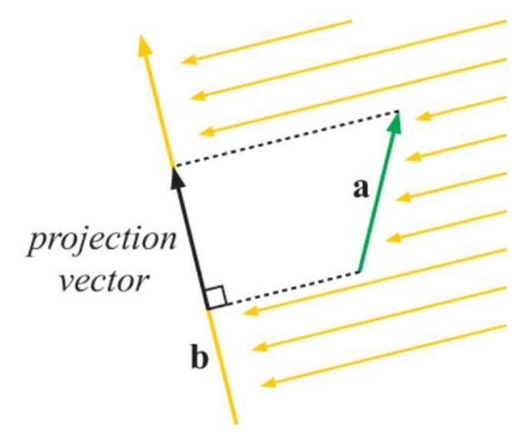 | If a light shines perpendicular to another vector $\overset{̰}{b}$, the shadow $\overset{̰}{a}$ casts onto vector $\overset{̰}{b}$ is called the projection of …… onto ………  This is the component of …… in the direction of ……

Sketch these projections. The first has been done for you.
- Projection of $\overset{̰}{a}$ onto $\overset{̰}{b}$  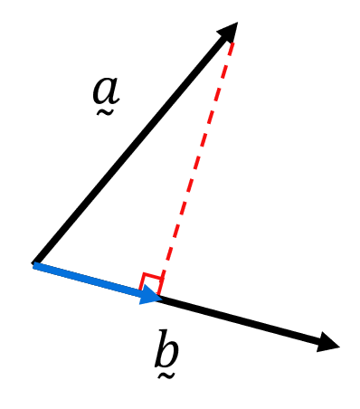 | - Projection of $\overset{̰}{a}$ onto $\overset{̰}{b}$ | - Projection of $\overset{̰}{b}$ onto $\overset{̰}{a}$  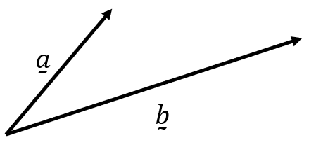
- Projection of $\overset{̰}{a}$ onto $\overset{̰}{b}$ | - Projection of $\overset{̰}{b}$ onto $\overset{̰}{a}$  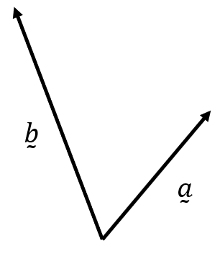 | - Projection of $\overset{̰}{a}$ onto $\overset{̰}{b}$
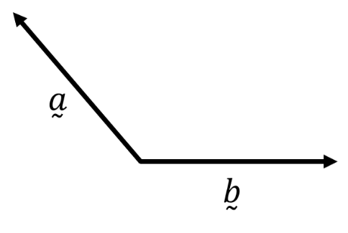  - Projection of $\overset{̰}{b}$ onto $\overset{̰}{a}$ | - Projection of $\overset{̰}{a}$ onto $\overset{̰}{b}$  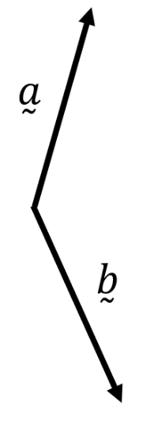 | - Projection of $\overset{̰}{b}$ onto $\overset{̰}{a}$

- Vector Projection
${proj}_{\overset{̰}{b}}\overset{̰}{a}$ is a vector.
${proj}_{\overset{̰}{b}}\overset{̰}{a}$ means the “projection of $\overset{̰}{a}$ onto $\overset{̰}{b}$”
${proj}_{\overset{̰}{b}}\overset{̰}{a}$ is the “shadow” of $\overset{̰}{a}$ cast onto the line containing $\overset{̰}{b}$.
${proj}_{\overset{̰}{b}}\overset{̰}{a}$ is the component of $\overset{̰}{a}$ parallel to $\overset{̰}{b}$.
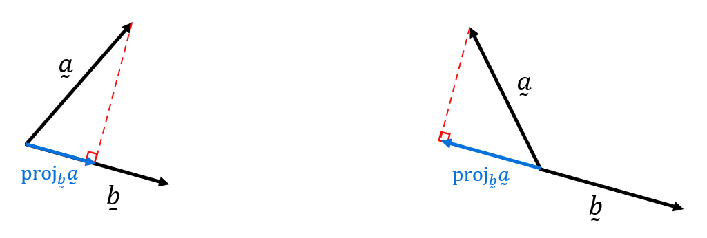

- Vector Projection Formula
${proj}_{\overset{̰}{b}}\overset{̰}{a}$ means the “projection of $\overset{̰}{a}$ onto $\overset{̰}{b}$”
$${proj}_{\overset{̰}{b}}\overset{̰}{a}=\left(\frac{\overset{̰}{a}⋅\overset{̰}{b}}{{\left|\overset{̰}{b}\right|}^{2}}\right)\overset{̰}{b} \\ =\left(\overset{̰}{a}⋅\hat{\overset{̰}{b}}\right)\hat{\overset{̰}{b}} using \hat{\overset{̰}{b}}=\frac{\overset{̰}{b}}{\left|\overset{̰}{b}\right|}$$
- Column notation is generally neater when working with vector projections.

- Example Calculate vector projection.
$\overset{̰}{a}=\left(\begin{aligned}2 \\ 3\end{aligned}\right), \overset{̰}{b}=\left(\begin{aligned}-3 \\ 5\end{aligned}\right)$. Find ${proj}_{\overset{̰}{b}}\overset{̰}{a}$and check your answer using the diagram.
$${proj}_{\overset{̰}{b}}\overset{̰}{a}=\left(\frac{\overset{̰}{a}⋅\overset{̰}{b}}{{\left|\overset{̰}{b}\right|}^{2}}\right)\overset{̰}{b}$$
$$=\left(\frac{\left(2\right)\left(-3\right)+\left(3\right)\left(5\right)}{{\left(-3\right)}^{2}+5^{2}}\right)\left(\begin{aligned}-3 \\ 5\end{aligned}\right)$$
$$=\frac{9}{34}\left(\begin{aligned}-3 \\ 5\end{aligned}\right)$$
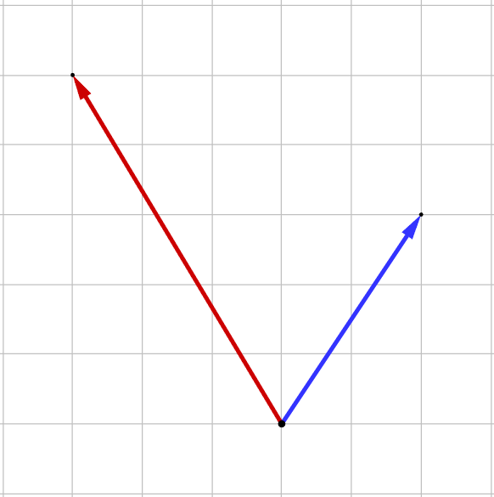

- Practice
$\overset{̰}{u}=5i-12j, \overset{̰}{v}=4i+3j$. Find ${proj}_{\overset{̰}{u}}\overset{̰}{v}$.
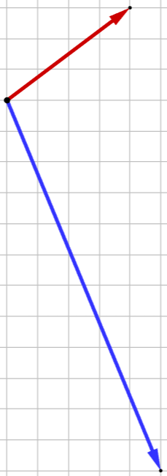

$$-\frac{16}{169}\left(\begin{aligned}5 \\ -12\end{aligned}\right)$$
- Proof of vector projection formula
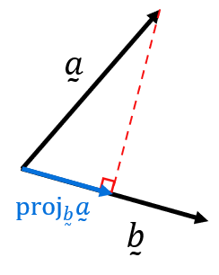
Consider the diagram. Our goal is to find a formula for ${proj}_{\overset{̰}{b}}\overset{̰}{a}$.

Let the angle between the vectors be $θ$.
Using right-angled trigonometry, relate the three sides of the triangle:

$$\cos{θ}=\frac{| |}{| |}$$

Using the dot product formula, we can write another formula for $\cos{θ}:$

$$\cos{θ}=$$

By equating the two formulas for $\cos{θ},$ we can derive the formula for ${proj}_{\overset{̰}{b}}\overset{̰}{a}$.

- Perpendicular Component Formula
To find the component of $\overset{̰}{a}$ perpendicular to $\overset{̰}{b}$, subtract the projection from $\overset{̰}{a}$:
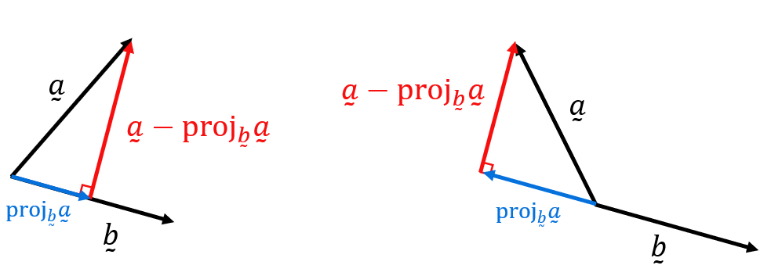
Perpendicular component = $\overset{̰}{a}-{proj}_{\overset{̰}{b}}\overset{̰}{a}$

- Check your answer by factorising and using $\left(\begin{aligned}x \\ y\end{aligned}\right)⊥λ\left(\begin{aligned}-y \\ x\end{aligned}\right) or λ\left(\begin{aligned}y \\ -x\end{aligned}\right)$
- This is also called the vector rejection of $\overset{̰}{a}$ from $\overset{̰}{b}$.

- Example Find perpendicular component.
Find the component of $\overset{̰}{a}=5i+2j$ perpendicular to $\overset{̰}{b}=4i+3j$
$${proj}_{\overset{̰}{b}}\overset{̰}{a}=\frac{\left(5\right)\left(4\right)+\left(2\right)\left(3\right)}{4^{2}+3^{2}}\left(\begin{aligned}4 \\ 3\end{aligned}\right)$$
$$=\frac{26}{25}\left(\begin{aligned}4 \\ 3\end{aligned}\right)$$
$$Perp component=\left(\begin{aligned}5 \\ 2\end{aligned}\right)-\frac{26}{25}\left(\begin{aligned}4 \\ 3\end{aligned}\right)$$
$$=\left(\begin{aligned}\frac{21}{25} \\ -\frac{28}{25}\end{aligned}\right)$$
$$=\frac{7}{25}\left(\begin{aligned}3 \\ -4\end{aligned}\right)$$
Notice that $\left(\begin{aligned}4 \\ 3\end{aligned}\right)$ and $\left(\begin{aligned}3 \\ -4\end{aligned}\right)$ are perpendicular vectors.

- Practice
Find the component of $\overset{̰}{a}=7i+j$ perpendicular to $\overset{̰}{b}=4i+3j$

$$\frac{17}{25}\left(\begin{aligned}3 \\ -4\end{aligned}\right)$$

Foundation
- Given $\underset{∼}{a}= \left(\begin{aligned}7 \\ -4\end{aligned}\right)$ and $\underset{∼}{b}= \left(\begin{aligned}12 \\ 6\end{aligned}\right),$ find:
- $proj_{b}a$  $$proj_{b}a=\left(\frac{\underset{∼}{a}·\underset{∼}{b}}{{\left|\underset{∼}{b}\right|}^{2}}\right)\overset{̰}{b} \\ \underset{∼}{a}·\underset{∼}{b}= 7\left(12\right)+ \left(-4\right)\left(6\right)= 60 \\ {\left|\underset{∼}{b}\right|}^{2}= 144 + 36 = 180 \\ proj_{b}a = \left(\frac{60}{180}\right)\left(\begin{aligned}12 \\ 6\end{aligned}\right)= \left(\begin{aligned}4 \\ 2\end{aligned}\right)$$ | - $proj_{a}b$  $$proj_{a}b=\left(\frac{\underset{∼}{b}·\underset{∼}{a}}{{\left|\underset{∼}{a}\right|}^{2}}\right)\underset{∼}{a} \\ {\left|\underset{∼}{a}\right|}^{2}= 49 + 16 = 65 \\ proj_{a}b = \left(\frac{60}{65}\right)\left(\begin{aligned}7 \\ -4\end{aligned}\right)$$

- Find $proj_{u}v$given:
- $\underset{∼}{u}= \left(\begin{aligned}3 \\ 6\end{aligned}\right)$  $$\underset{∼}{v}= \left(\begin{aligned}-2 \\ 6\end{aligned}\right)$$  $$\underset{∼}{u}·\underset{∼}{v}= 3\left(-2\right)+ 6\left(6\right)= 30 \\ {\left|\underset{∼}{u}\right|}^{2}= 9 + 36 = 45 \\ proj_{u}v= \left(\frac{30}{45}\right)\left(\begin{aligned}3 \\ 6\end{aligned}\right)= \left(\begin{aligned}2 \\ 4\end{aligned}\right)$$ | - $\underset{∼}{u}= -3i - 2j$  $$\underset{∼}{v}= 4i - 19j$$  $$\underset{∼}{u}·\underset{∼}{v}= \left(-3\right)\left(4\right)+ \left(-2\right)\left(-19\right)= 26 \\ {\left|\underset{∼}{u}\right|}^{2}= 9 + 4 = 13 \\ proj_{u}v= \left(\frac{26}{13}\right)\left(-3i∼ - 2j\right)= -6i- 4j$$

- Given $\underset{∼}{u}= \left(\begin{aligned}2 \\ 1\end{aligned}\right)$ and $\underset{∼}{v}= \left(\begin{aligned}3 \\ -4\end{aligned}\right),$ find:
- $proj_{v}u$  $$proj_{v}u =\left(\frac{\underset{∼}{u}·\underset{∼}{v}}{{\left|\underset{∼}{v}\right|}^{2}}\right)\underset{∼}{v} \\ \underset{∼}{u}·\underset{∼}{v}= 2\left(3\right)+ 1\left(-4\right)= 2 \\ {\left|\underset{∼}{v}\right|}^{2}= 9 + 16 = 25 \\ proj_{v}u = \left(\frac{2}{25}\right)\left(\begin{aligned}3 \\ -4\end{aligned}\right)= \left(\begin{aligned}0.24 \\ -0.32\end{aligned}\right)$$ | - $proj_{u}v$  $$proj_{u}v=\underset{∼}{\left(\frac{\underset{∼}{v}·\underset{∼}{u}}{{\left|\underset{∼}{u}\right|}^{2}}\right)u} \\ {\left|\underset{∼}{u}\right|}^{2}= 4 + 1 = 5 \\ proj_{u}v = \left(\frac{2}{5}\right)\left(\begin{aligned}2 \\ 1\end{aligned}\right)= \left(\begin{aligned}0.8 \\ 0.4\end{aligned}\right)$$
- $| proj_{v}u |$  $$\sqrt{{0.24}^{2}+ {0.32}^{2}}= 0.4$$ | - The direction of $proj_{v}u$  $$\tan^{-1}\left(-\frac{0.32}{0.24}\right)= \tan^{-1}\left(-\frac{4}{3}\right) in Q4 \\ θ = 360° - 53° = 307°$$

- Find the projection of $\underset{∼}{a}$ onto $\underset{∼}{b}$ if:
- $\underset{∼}{a}= i + j,$  $$\underset{∼}{b}= i$$  $$\underset{∼}{i}$$ | - $\underset{∼}{a}= i + 2j,$  $$\underset{∼}{b}= j$$  $$2\underset{∼}{j}$$ | - $\underset{∼}{a}= -3i + 2j,$  $$\underset{∼}{b}= i$$  $$-3\underset{∼}{i}$$

- Find the projection of $\underset{∼}{a}$ onto $\underset{∼}{b}$ if:
- $\underset{∼}{a}= \left(\begin{aligned}2 \\ 1\end{aligned}\right),\underset{∼}{b}= \left(\begin{aligned}4 \\ 0\end{aligned}\right)$  $$\underset{∼}{a}·\underset{∼}{b}= 2\left(4\right)+ 1\left(0\right)= 8 \\ {\left|\underset{∼}{b}\right|}^{2}= 16 \\ proj_{b}a = (8/16)(█(4@0)) = \left(\begin{aligned}2 \\ 0\end{aligned}\right)$$ | - $\underset{∼}{a}= 3i+ 3j$  $$\underset{∼}{b}= 2j$$  $$\underset{∼}{a}·\underset{∼}{b}= 3\left(0\right)+ 3\left(2\right)= 6 \\ {\left|\underset{∼}{b}\right|}^{2}= 4 \\ proj_{b}a = \left(\frac{6}{4}\right)\left(\underset{∼}{2j}\right)=\underset{∼}{3j}$$ | - $\underset{∼}{a}= \left(\begin{aligned}5 \\ -3\end{aligned}\right),\underset{∼}{b}= \left(\begin{aligned}-6 \\ 0\end{aligned}\right)$  $$\underset{∼}{a}·\underset{∼}{b}= 5\left(-6\right)+ \left(-3\right)\left(0\right)= -30 \\ {\left|\underset{∼}{b}\right|}^{2}= 36 \\ proj_{b}a = \left(-\frac{30}{36}\right)\left(\begin{aligned}-6 \\ 0\end{aligned}\right)=\left(\begin{aligned}5 \\ 0\end{aligned}\right)$$

- Use trigonometry to find the length of the projection of $\vec{OA}$ onto $\vec{OB}$ if:
Hint: draw a diagram.
- $|\vec{OA}| = 6$ and ∠AOB = 30°  $$\left|\vec{OA}\right|cos 30° = 6 × \left(\frac{\sqrt{3}}{2}\right)= 3\sqrt{3}$$ | - $|\vec{OA}| = 6\sqrt{6}$ and ∠AOB = 45°  $$6\sqrt{6}× cos 45° = 6\sqrt{6}× \left(\frac{\sqrt{2}}{2}\right)= 3\sqrt{12}= 6\sqrt{3}$$

- Show that the projection of $\underset{∼}{a}= \left(\begin{aligned}10 \\ -2\end{aligned}\right)$ onto $\underset{∼}{b}= \left(\begin{aligned}1 \\ -7\end{aligned}\right)$ has length $\frac{12\sqrt{2}}{5}$.

$$\underset{∼}{a}·\underset{∼}{b}= 10\left(1\right)+ \left(-2\right)\left(-7\right)= 24 \\ \left|\underset{∼}{b}\right|= \sqrt{50}= 5\sqrt{2} \\ \left|{proj}_{b}a\right|=\frac{\left|\underset{∼}{a}·\underset{∼}{b}\right|}{\left|\underset{∼}{b}\right|}=\frac{24}{5\sqrt{2}}=\frac{24\sqrt{2}}{10}=\frac{12\sqrt{2}}{5}$$

- Find the component of $\underset{∼}{a}$ in the direction of $\underset{∼}{b}$ if:
- $\underset{∼}{a}= i + j,\underset{∼}{b}= 3i + j$  $$\underset{∼}{a}·\underset{∼}{b}= 1\left(3\right)+ 1\left(1\right)= 4 \\ {\left|\underset{∼}{b}\right|}^{2}= 10 \\ {proj}_{b}a= \left(\frac{4}{10}\right)\left(\underset{∼}{3i}+\underset{∼}{j}\right)=\underset{∼}{\left(\frac{6}{5}\right)i}+\underset{∼}{\left(\frac{2}{5}\right)j}$$ | - $\underset{∼}{a}= 4i - 3j,\underset{∼}{b}= 6i + 2j$  $$\underset{∼}{a}·\underset{∼}{b}= 4\left(6\right)+ \left(-3\right)\left(2\right)= 18 \\ {\left|\underset{∼}{b}\right|}^{2}= 40 \\ {proj}_{b}a= \left(\frac{18}{40}\right)\left(\underset{∼}{6i}+\underset{∼}{2j}\right)= \left(\frac{9}{20}\right)\left(\underset{∼}{6i}+\underset{∼}{2j}\right)=\underset{∼}{\left(\frac{27}{10}\right)i}+\underset{∼}{\left(\frac{9}{10}\right)j}$$

Development
- Find the magnitude of $\underset{∼}{a}$ in the direction of $\underset{∼}{b}$ if:
- $\underset{∼}{a}= -2i,\underset{∼}{b}= -3i - 2j$  $$\underset{∼}{a}·\underset{∼}{b}= \left(-2\right)\left(-3\right)+ 0\left(-2\right)= 6 \\ \left|\underset{∼}{b}\right|= \sqrt{13} \\ \left|{proj}_{b}a\right|=\frac{6}{\sqrt{13}}$$ | - $\underset{∼}{a}= 6i - 4j,\underset{∼}{b}= -3i + 6j$  $$\underset{∼}{a}·\underset{∼}{b}= 6\left(-3\right)+ \left(-4\right)\left(6\right)= -18 - 24 = -42 \\ \left|\underset{∼}{b}\right|= \sqrt{45}= 3\sqrt{5} \\ \left|{proj}_{b}a\right|=\frac{\left|-42\right|}{3\sqrt{5}}=\frac{14}{\sqrt{5}}$$

- Find the projection of $\vec{AB}$ onto $-6i+4j$given $A(-3, -7)$ and $B(1, 5)$.

$$\vec{AB} = (1-(-3), 5-(-7)) = \left(4, 12\right) \\ \underset{∼}{b}= --6i+4j \\ \vec{AB} ·\underset{∼}{b}= 4\left(-6\right)+ 12\left(4\right)= -24 + 48 = 24 \\ {\left|\underset{∼}{b}\right|}^{2}= 36 + 16 = 52 \\ {proj}_{b}\vec{AB} = \left(\frac{24}{52}\right)\left(-6i+4j\right)= \left(\frac{6}{13}\right)\left(-6i+4j\right)= -\left(\frac{36}{13}\right)i+\left(\frac{24}{13}\right)j$$

- Find the length of the projection of $\vec{AB}$ onto $\vec{CD}$ given $A(1, 3), B(6, 18), C(9, 4)$ and $D(19, 24)$.

$$\vec{AB} = (5, 15), \vec{CD} = (10, 20) \\ \vec{AB} · \vec{CD} = 50 + 300 = 350 \\ \left|\vec{CD}\right|= \sqrt{500}= 10\sqrt{5} \\ \left|{proj}_{\vec{CD}}\vec{AB} \right| =\frac{350}{10\sqrt{5}}=\frac{35}{\sqrt{5}}= 7\sqrt{5}$$

- Find the possible values of $λ$ if the projection of $λi+ 4j$ onto $12i- 5j$ has length $\frac{140}{13}$.

$$proj of λi+4j onto 12i-5j \\ Dot product = 12λ - 20 \\ \left|12i-5j\right| = 13 \\ \left|proj\right|=\frac{\left|12λ - 20\right|}{13}=\frac{140}{13} \\ \left|12λ - 20\right|= 140 \\ 12λ - 20 = 140 or 12λ - 20 = -140 \\ 12λ = 160 or 12λ = -120 \\ λ =\frac{40}{3}or -10$$

Mastery

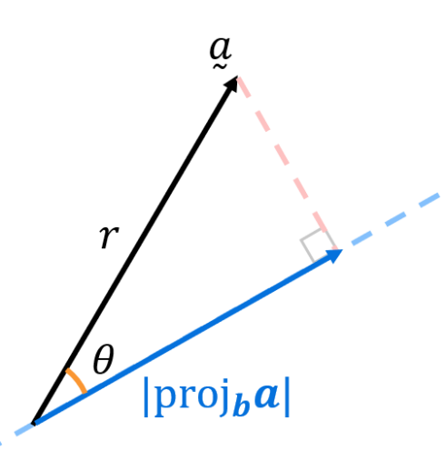
  - Given vectors $\overset{̰}{a}$ and $\overset{̰}{b}$ with angle $θ$ between them and $\left|\overset{̰}{a}\right|=r$,
prove, using the vector projection and dot product formulas, that the magnitude of the component of vector $\overset{̰}{a}$ parallel $\overset{̰}{b}$, $|proj_{b}a|$, is $r\cos{θ}$.

$$proj_{b}a =\left(\frac{\underset{∼}{a}·\underset{∼}{b}}{{\left|\underset{∼}{b}\right|}^{2}}\right)\underset{∼}{b} \\ \left|proj_{b}a \right|= \left|\frac{\underset{∼}{a}·\underset{∼}{b}}{{\left|\underset{∼}{b}\right|}^{2}}\right|× \left|\underset{∼}{b}\right| \\ =\frac{\left|\underset{∼}{a}·\underset{∼}{b}\right|}{\left|\underset{∼}{b}\right|} \\ Using \underset{∼}{a}·\underset{∼}{b}= \left|\underset{∼}{a}\right|\left|\underset{∼}{b}\right|cos θ: \\ =\frac{\left|\underset{∼}{a}\right|\left|\underset{∼}{b}\right|cos θ}{\left|\underset{∼}{b}\right|} \\ = \left|\underset{∼}{a}\right|cos θ \\ = r cos θ$$

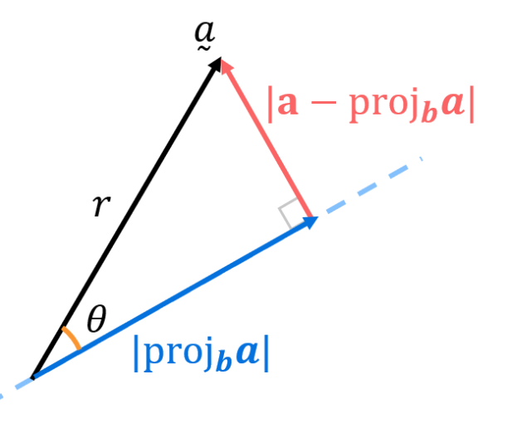
  - Prove, using the result in part a and Pythagoras’ Theorem, that the rejection magnitude $|a-proj_{b}a|$is $r\sin{θ}$.

$${\left|a-proj_{b}a \right|}^{2}={\left|\overset{̰}{a}\right|}^{2}-|proj_{b}a {\left.​\right|}^{2} \\ =r^{2}-r^{2}\cos^{2}{θ} \\ =r^{2}\left(1-\cos^{2}{θ}\right) \\ =r^{2}\sin^{2}{θ} \\ ∴\left|a-proj_{b}a \right|=r\sin{θ}$$

